**The British College**

**KATHMANDU**

**Coursework Submission Coversheet**(individual coursework only)

**Faculty of Arts, Environment and Technology LBU Student Id:**

**77356818**

**For checking by the student:**

Please ensure all information is complete and correct and attach this form securely to the front of your work before posting it in a coursework collection box.

Award name: Bsc Hons in Computing

Module code: 15781-AUT-202110

Module name: Advance Database System (ADS)

Module run: 2024/2025

Coursework title: Data warehouse Design and Development

Due Date: 20th January 2025

Module leader: (In LBU): Jackie Campbell, Sanela Lazarevski

Module tutor: (In TBC): Dibya Tara Shakya

**TURNITIN** Checked: YES NO ***(please circle)***

Submission date& time: Date: Time: Before noon

**Total Word Count: Total Number of Pages (including this front sheet):**

**In submitting this form with your assignment, you make the following declaration:**  
I declare, that the coursework submitted is my own work and has not (either in whole or part) been submitted towards the award of any other qualification either at LBU or elsewhere. I have fully attributed/referenced all sources of information used during the completion of my assignment, and I am aware that failure to do so constitutes an assessment offence.

Signed: Shambu Prasad Sah Date:

**You are strongly advised to retain a second copy of your work in case of any query about the assignment.**

**For completion by the faculty:**

**This mark is provisional and subject to moderation and approval by the relevant examining board**

**Teacher's Feedback**

**Teacher's Signature: __________________________________ Date: _________________**

Table of Contents

Data analysis /OLAP/Mining Investigation 4

Data Analysis 4

OLAP 4

OLAP Operations: 4

Data Mining 5

Data Mart 5

Dependent Data Mart: 6

Independent Data Mart: 6

Advantage of using Data Mart: 6

Business Intelligence 7

Report 8

1. Apex Report 8

**Dashboard** 8

**i.** **Crime Distribution by Station/Region** 8

**Top Crime Location Ranking** 9

**Crime Severity by Station/Region** 11

**Crime Type Concentration by Area** 12

**Crime Frequency by Station and Time Period** 14

2. Tableau 15

**0.** **Dashboard** 15

**1.** **Police Station Comparison by Crime Types** 16

**2.** **Crime Resolution Efficiency by Region** 18

**3.** **Crime Trend Analysis** 19

**4.** **Crime Trends Over Time** 20

**5.** **Police Station Performance** 21

EXCEL Report 22

**Dashboard** 22

**Total Station by Resolved Crime** 22

**Crime type by region** 23

**Repeated offence by station** 24

**Most Crime in Month** 25

**Total Crime by City** 26

Task – 2 28

Data Maintenance 28

Vertical and Horizontal Partitioning 29

Slowly Changing Dimensions 33

**Type 0: Fixed Dimension** 33

**Type 1: Overwrite** 33

**Type 2: Add a New Row** 34

**Type 3: Add a New Column** 36

Package, Function and Procedure 38

Transformation Table Package 38

Dim Table Load Data Package 40

Staging Table and cleaning Package, Procedure 42

# **Data analysis /OLAP/Mining Investigation**

## **Data Analysis**

Data analysis is the identification and interpretation of data for the purpose of finding the insight, decision-making, and solve problems. It involves data gathering from different sources then scrubbing to remove any erroneous point. The qualitative analysis follows the conversion of the data into a format that is readily for analysis. Exploratory Data Analysis (EDA) is analysing the data about the variables in a set to look for various patterns including outliers and trends. The patterns are further examined through hypothesis testing and to determine the phenomenon’s relationships the researchers may model the outcome. In conclusion, analysis of the results is done and presented using such things as natural language, data visualization, or report form for the benefit of the stakeholders. This process is basic in business intelligence, research and data analysis hence helps organizations to use data for competitive intelligence.

## **OLAP**

OLAP (Online Analytical Processing) is a category of data processing that involves letting the user to analyse the data from various aspects and with different perspective. It enables users to filter, sort and calculate results from large data repositories for the reason of decision support and data analysis. OLAP systems allow the users to gain fast and easy access to the information so that decision making process concerning company performance and other factors could be made as fast as possible.

In OLAP, data is normally enriched within multidimensional model, where every dimension corresponds to a topical aspect of data, for example, time, location, or product type. The fundamental building block is the concept of the “cube”, which holds the data concerning these dimensions; users may then choose to “slice” (view subset data), “dice” (view data from another angle), “drill down” (view more detailed data), or “roll up” (view aggregated data).

## OLAP Operations:

There are five basic analytical operations that can be performed on an OLAP cube:

**Drill Down**

Drill down operation allows a user to zoom in on the data cube i.e., the less detailed data is converted into highly detailed data. It can be implemented by either stepping down a concept hierarchy for a dimension or adding additional dimensions to the hypercube.

**Roll up**

It is the opposite of the drill-down operation and is also known as a drill-up or aggregation operation. It is a dimension-reduction technique that performs aggregation on a data cube. It makes the data less detailed and it can be performed by combining similar dimensions across any axis.

**Dice**

Dice operation is used to generate a new sub-cube from the existing hypercube. It selects two or more dimensions from the hypercube to generate a new sub-cube for the given data.

**Slice**

Slice operation is used to select a single dimension from the given cube to generate a new sub-cube. It represents the information from another point of view.

**Pivot**

It is used to provide an alternate view of the data available to the users. It is also known as Rotate operation as it rotates the cube’s orientation to view the data from different perspectives.

## **Data Mining**

Data mining is the process of discovering useful knowledge from large amount of data through application of statistical tools, artificial neural networks, decision trees, and other relevant techniques. It encompasses massive data analysis to detect different patterns, connections and dependencies that would help in decision making and decision forecasting. Frequent methods used in data mining includes classification, whereby data is separated into categories; clustering, whereby similar data sets are grouped together; association rule mining that assigns related variables; regression which predicts continuous values and anomaly detection which is used in recognizing outlying patterns. Data mining is implemented in various industries including financial, marketing, healthcare, and retail industries among others to enable an organization draw trend, enhance operations and customers’ targeting. With data mining, businesses are therefore able to find hidden knowledge in detail in order to make better decisions and beat the competition.

## **Data Mart**

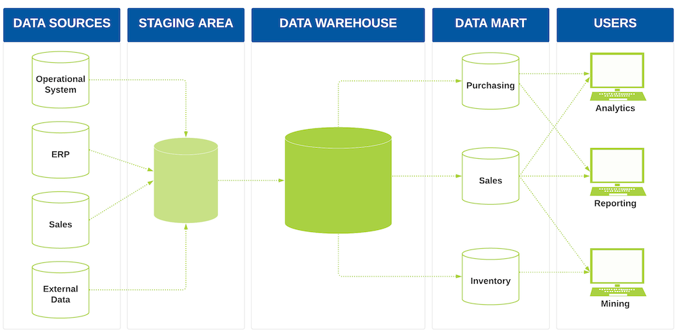

A data mart is a part of a data warehouse that is oriented to, and used by, only one department, division, or business unit of an organization. It holds a set of information that will be useful to a specific set of consumers, for instance sales, marketing, finance or operations. It is also important therefore to note that data marts are generally less extensive than data warehouses and because of this are optimized to deliver quick query response and to provide the more relevant data to the user.

Data marts can be created from subsets of a data warehouse, extracted and transformed, or can be developed on their own from data in operational systems as well as external sources. The essence of a data mart is to build a customized and easy-to-use tool for business analysts and decision-makers for retrieving, analysing and reporting the data most appropriate to the tasks they perform.

**There are two main types of data marts:**

**Dependent Data Mart:** This type of data mart is made by extracting data from a current data warehouse. It makes a data mart compatible with a data warehouse and uses the same data model as well.

**Independent Data Mart:** An independent type of this data mart does not have to depend on a central data warehouse environment. It may obtain data from operational systems or from other sources outside the organization.

Data marts are very important because they help in fulfilling the goals of BI by allowing specific departments or a certain team to view and analyse data which will be most relevant to its work, without having to go through the complex process of using a data warehouse. As well they also assist in taking some of the amount that is required to be queried in a data warehouse off which will better its performance and speed of response to queries.

## **Advantage of using Data Mart:**

The advantages of using a data mart include:

1. **Faster Query Performance:** Data marts are subsets of data warehouses but are smaller and more specific which makes it easier to extract data from them. This results in timesaving since clients are able to get rid of browsing large quantities of information, which they may not need.
2. **Tailored for Specific Business Needs:** Data marts are oriented to serve the specific needs and requirements of certain department or business function, for example, marketing or sales or financials. This specialization enables the user not only to retrieve the data that they work with within their sphere but also analyse it to optimise the decision-making process and work in general.
3. **Reduced Complexity:** They provide a subset of data relevant to a certain area of the organization thereby reducing on the data complexity as the DW users can query and analyse the data without any complex issues related in an enterprise-wide data warehousing system.
4. **Cost-Effective:** Data marts are often even less costly to implement and manage in comparison with a large and complex data warehouse since the latter does not necessarily demand extensive structures and technologies. Reduced data needs decrease the ability required for mass capacity and sophisticated data analysis tools.
5. **Improved Data Accessibility:** The advantage of data marts is that the business user can get the information he wants and needs without having to rely on the IT or data warehouse administrators. This self-service access puts more decision making power in the hands of the user to enable them make decision on their own at a faster pace.
6. **Scalability:** Data marts can be built incrementally or in a flexible manner to cater changes in business requirements. Other new marts can be created for other departments or business functions for the organisation and all of this means that organisations can grow the data marts in its organisation systematically.
7. **Enhanced Security and Data Control:** Since data marts are dedicated to particular business procedures, it is possible to limit the access to the sensitive information with the help of specific departments only. This as in a way improves the security of the information and the ability to manage the data received.

## **Business Intelligence**

According to West, Business Intelligence or BI otherwise known as Decision Support Information is the technology, process and tools for collecting, integrating, analysing and reporting business information to support the decision-making process. BI is used in organizations to transform a business into an insightful learning process, refine enterprises, and enhance the execution procedures. It involves acquiring data from local databases, spread sheets as well as other external data feed to clean it, sort and look for patterns and possibilities.

As related to BI systems, the techniques that are implemented are data mining, reporting, data dashboarding and data visualization.

These tools help businesses to:

1. **Monitor Performance:** Monitor the disclosure of most relevant KPIs, financial and operational performances in real time.
2. **Analyze Trends:** Diagnose data to identify trends so as to make predictions which involves sales, demand and even customer behaviors, in future.
3. **Improve Efficiency:** Development of methods for detecting possible inefficiencies at the various organizational levels, improving organizational processes and increasing the effectiveness of resource use.
4. **Support Strategic Planning:** Make it easy for the executives to look for data in order to come up with long term decisions of the business, expansion, mergers, or capital investments.

Popular analytical BI tools sometimes require data warehousing, where data from multiple systems are collected for analysis and OLAP, which allows for multiple analyses of the data. Today’s BI systems are also exponential using of utilizing machine learning and artificial intelligence to give more accurate and predicting results.

In sum, Business Intelligence helps organizations to leverage their capabilities as to provide the better response to market fluctuations thus increasing competitiveness.

# **Report**

## **Apex Report**

### **Dashboard**

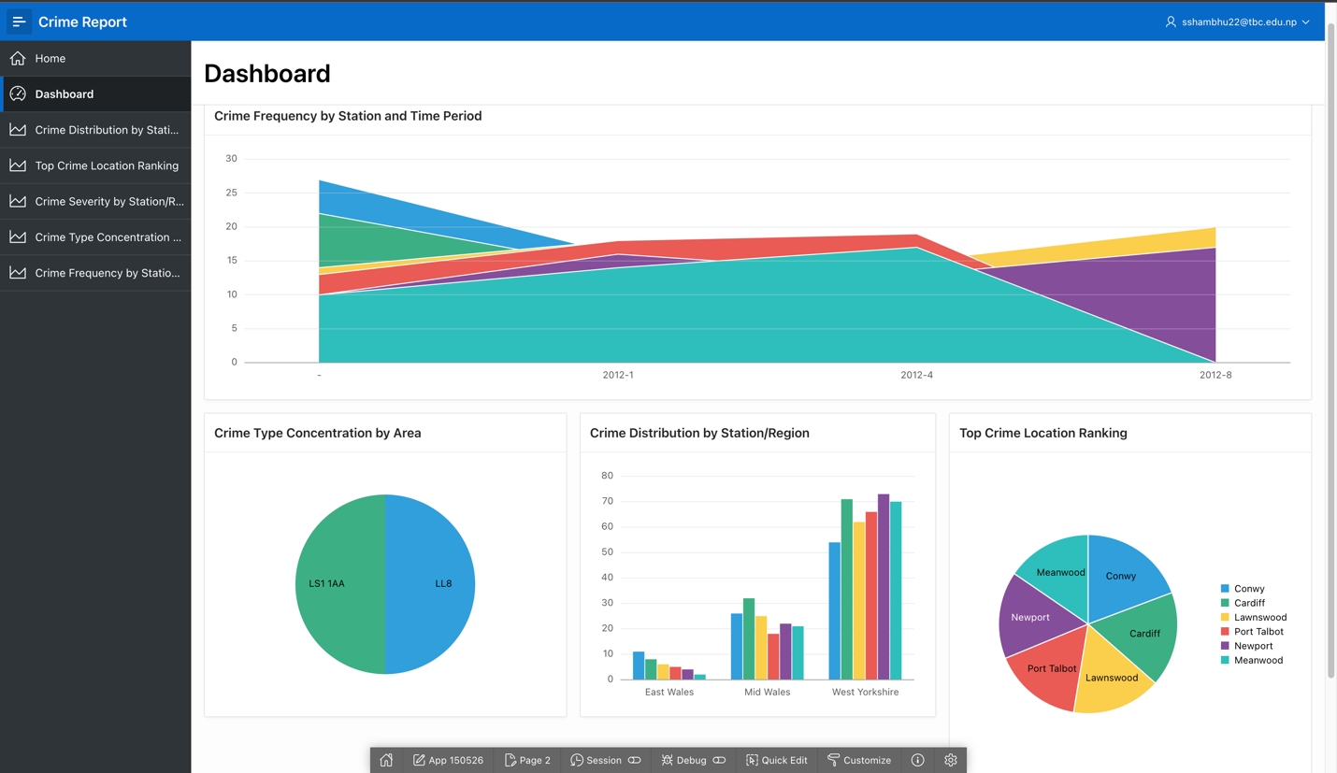

### **Crime Distribution by Station/Region**

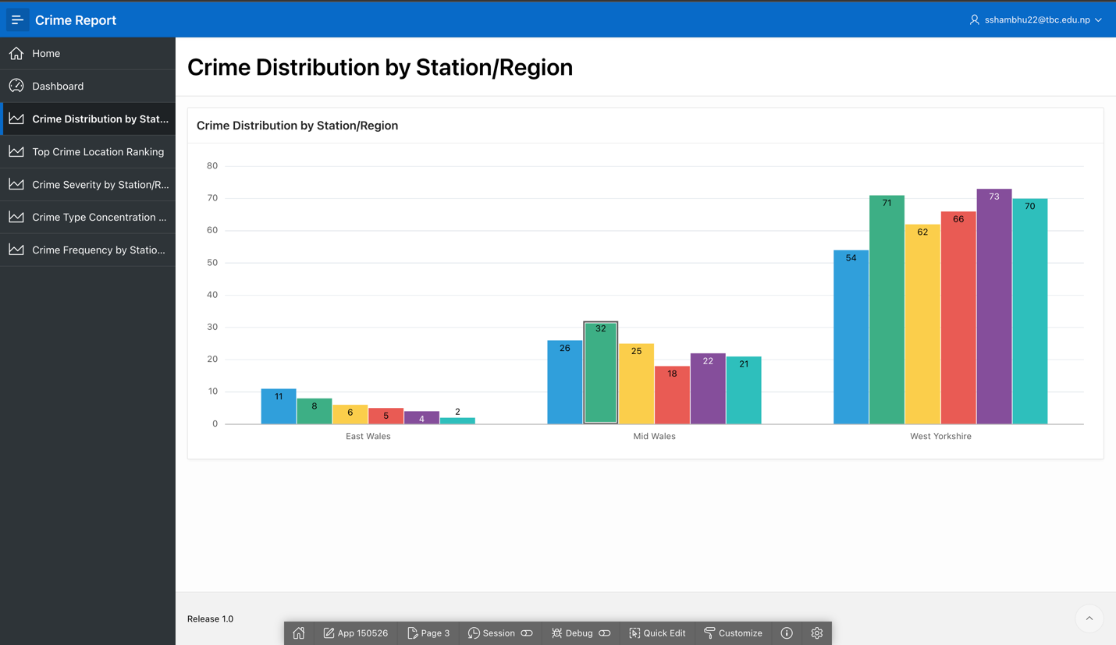

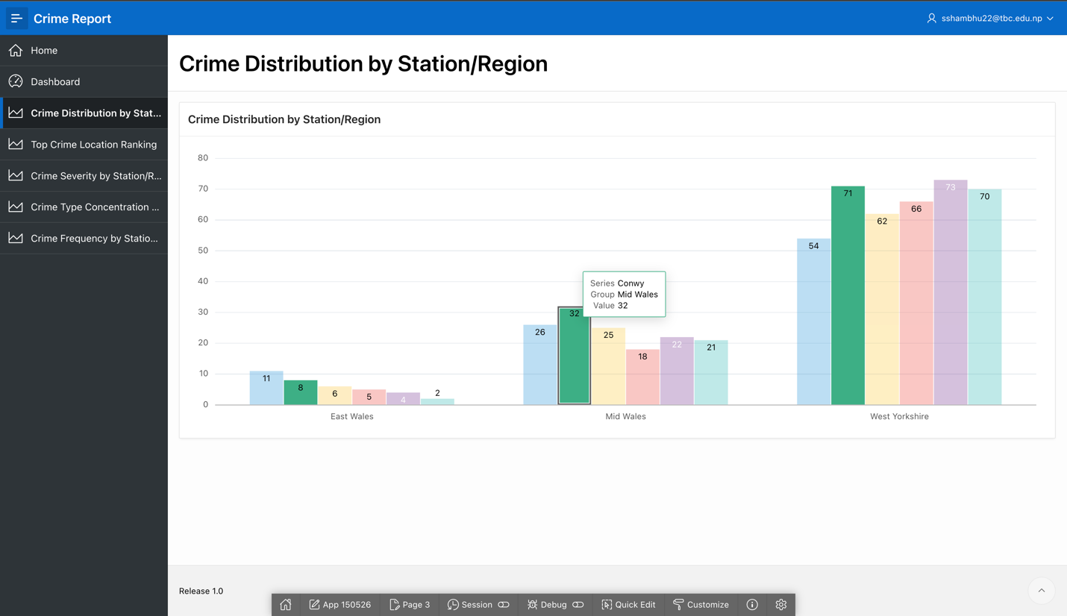

**Analysis**

The data shows the distribution of crimes across police stations in three regions: East Wales, Mid Wales and West Yorkshire. West Yorkshire is the most affected location with highest counts of crime across all explored stations and Cardiff, Conwy and Port Talbot specifically. Mid Wales also provide rather high numbers of crime and the highest number of crime rates indicates Conwy and Newport. Comparatively, the East Wales region shows a lot less crime density, Newport being the worst affected region in East Wales but they are a lot less than any of the other regions noted above. Both Conwy and Newport are present in all three regions and the differing crime rate suggest they are useful variables in analysing regional crime.

**Synopsis**

It is shown that West Yorkshire is a region that registers high crime rates most of the times with higher counts compared to the two stations namely East Wales and Mid Wales. Mid Wales also appears to have distinct crimes but not to the extent of West Yorkshire. East Wales has the entire least rate of total crime, this may be due to effective policing or least chance for crime to happen. Often towns such as Conwy, Newport, Cardiff are mentioned with high numbers of crime and this implies that the government has to address targeted areas with relevant safety measures and crime preventive measures if any to be observed to prevent the high escalation of crime.

### **Top Crime Location Ranking**

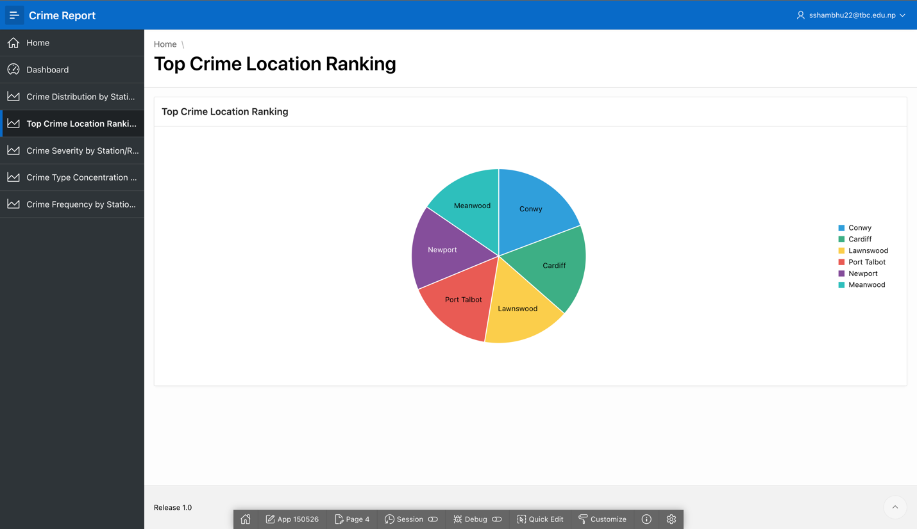

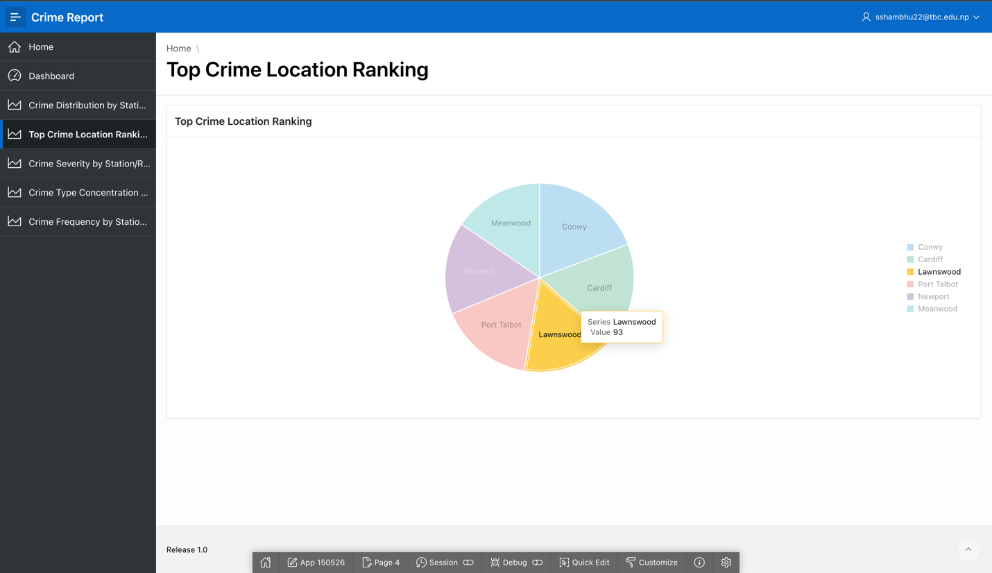

**Analysis**

The query also includes the entire value of total counts of crime for selecting the top 10 police station. From the output it is observed that Conwy has registered the overall reported crimes of 111, and Cardiff with 99. They both have 93 crime counts and are ranked the third place between Lawnswood and Port Talbot. Newport (91) and Meanwood (89) grade placements are also close behind. Such stations contribute a large proportion of the entire crimes, which indicates that they are crime ‘hot’ spots that need much attention from the authorities.

**Synopsis**

The analysis of crime reports shows that Conwy tops it, although several stations are almost at the same level of crime – Cardiff, Lawnswood, and Port Talbot stations. This shows that these places have more criminal incidences and, therefore, must be crucial for designated law enforcement measures. In general, it is raising the need to ensure those areas are intervened so as to solve the issue of insecurity and fight achievements of the crime rates.

### **Crime Severity by Station/Region**

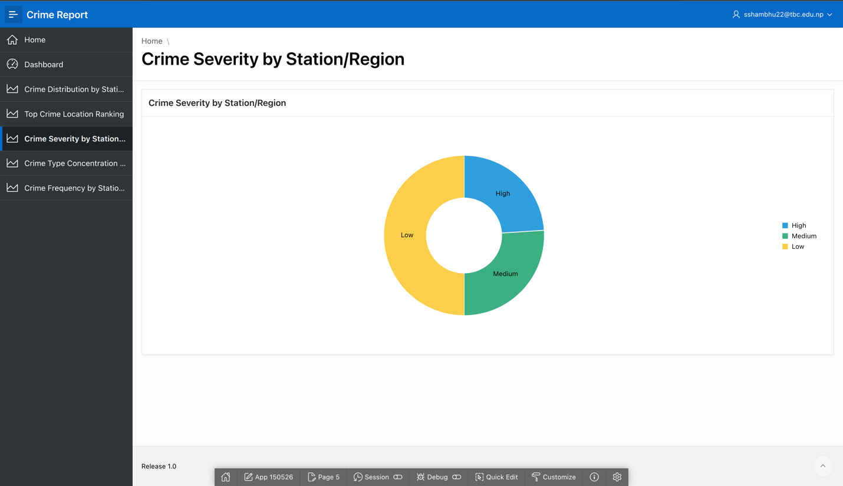

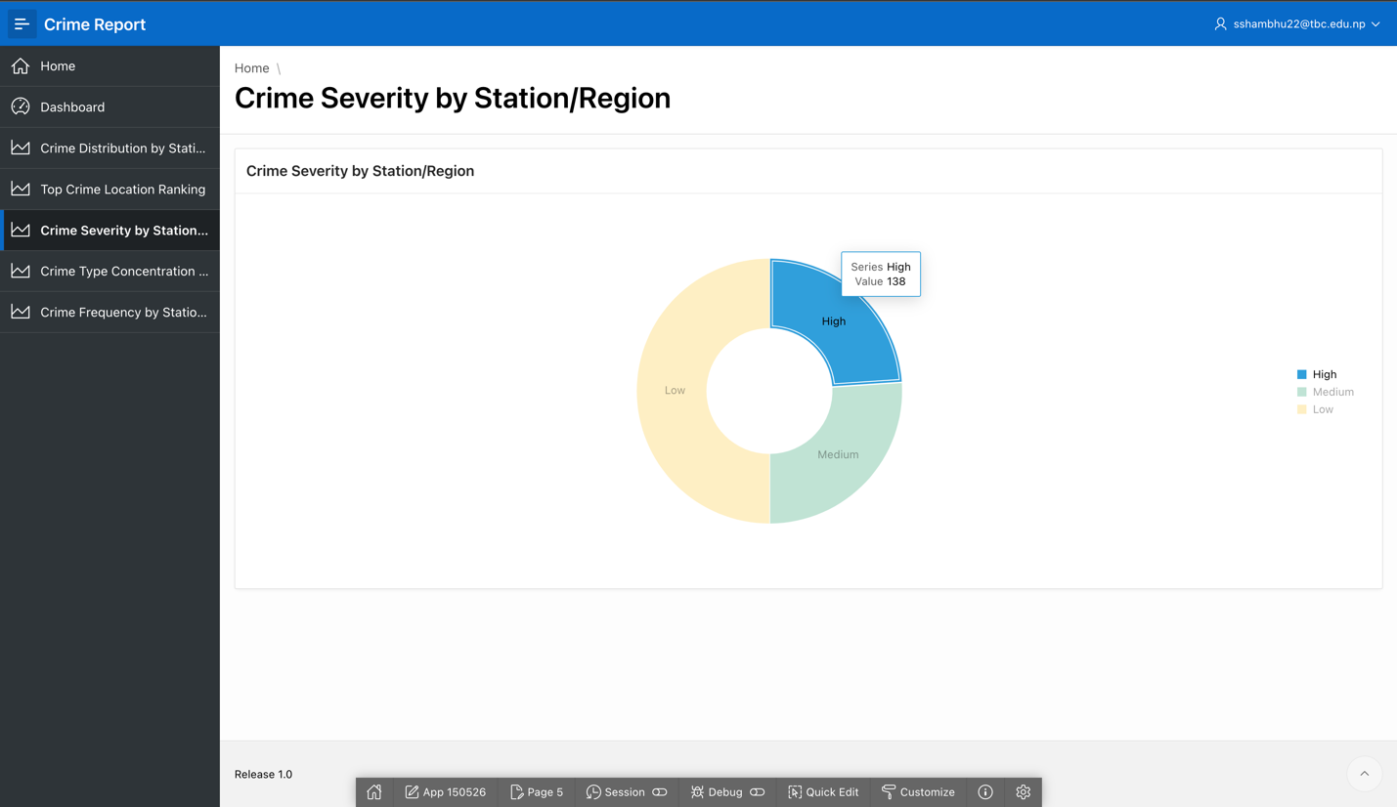

**Analysis**

The query categorizes crimes into three severity levels: Severe, moderate and mild grouped under High, Medium and Low, depending on the values of crime_severity. The following table reveals that Low-severity crimes contributed to the largest number with 288. Medium severity crimes come second with a total of 150 cases recorded while high severity crimes with only 138. This distribution means that even though low-severity crimes are less frequent than high-severity crimes, they might also need much attention in case they cause an effect.

**Synopsis**

The analysis reveals the fact of dominating Low and Medium severity types of crime occurrences, while High severity crime occurrences are less frequent. However, each of these three needs to be handled using a unique approach to crime management. While there are fewer in number, some may need particular attention and preventative undertaking, based on their severity; the high quantity of low severity offenses may suggest that the corresponding precinct/s may need increased public outreach and patrol for handling of relatively minor offenses.

### **Crime Type Concentration by Area**

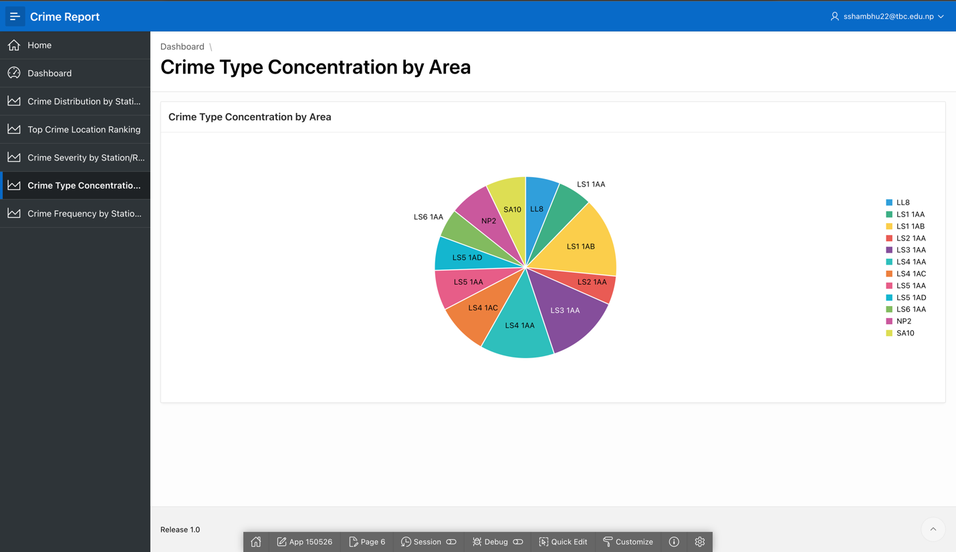

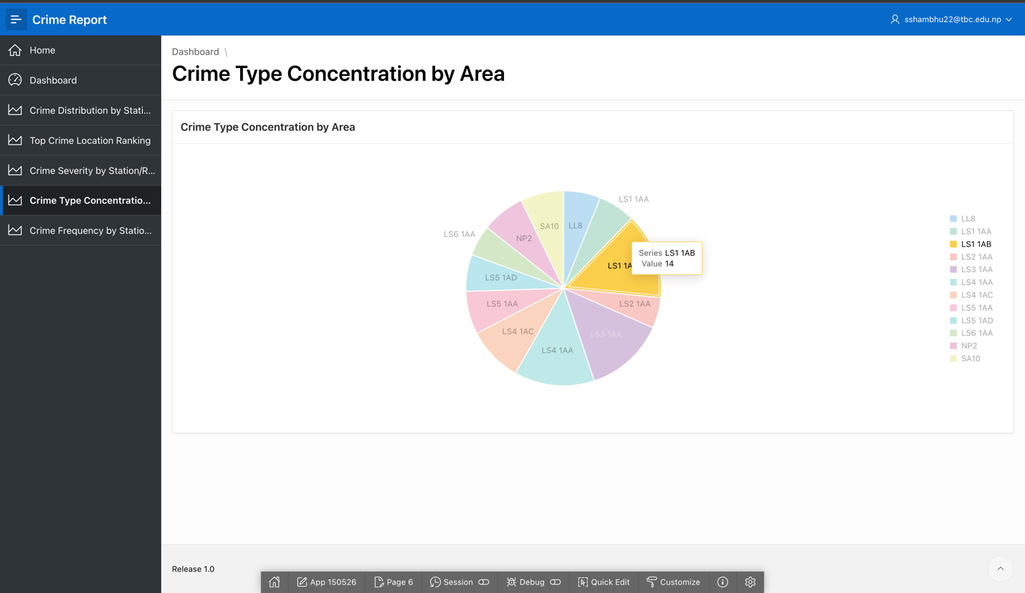

**Analysis**

The query gives a clear analysis of the kind of crimes committed per section with a list of crimes listed in accordance to the number of times they occurred. The work analyzed has also established the variation that exists in the different types of crimes in distinct regions. For example:

LL8 reports the highest values of Robbery (6) while Blackmailing and Kidnapping have both recorded 5, showing that the company has strong interest in violent an serious crimes.

Some of the listed crimes include; Armed Robbery which has 6 instances and Forgery with 4 occurrences, Car Theft also including Drunk and Drive.

LS4 1AA has the highest forgery rate (13) and other special crimes such as armed robbery, and hit and run with the same rate (7).

Other areas include NP2, SA10, violent crime forgery drunk and disorder, with numerous minor and serious crimes.

This information shows the way criminals are distributed and some areas can be associated with violence involving serious crimes some with property related or less serious offenses.

**Synopsis**

The mapping shows various concentration of crimes as well as several crimes such as Forgery, Robbery and Violent Crime that are manifested in several areas. Places such as LL8, LS4 1AA, LS1 1AB become specific crime ‘hot spots’ requiring specific policing interventions. The distribution supports the call for conforming plans for instituting crime types across areas including the intensification of patrols in violent crime areas and surveillance of areas associated with property crimes.

### **Crime Frequency by Station and Time Period**

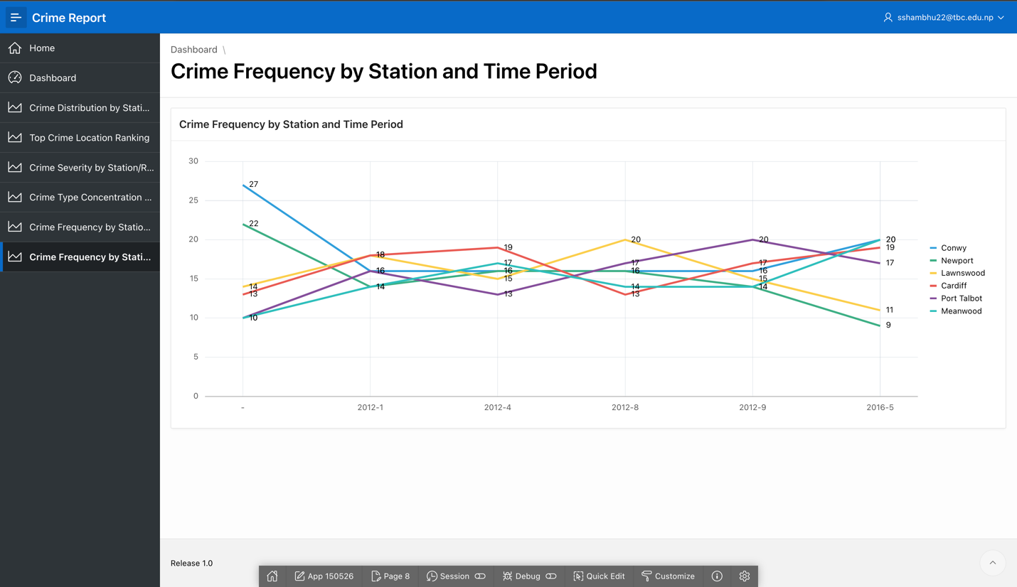

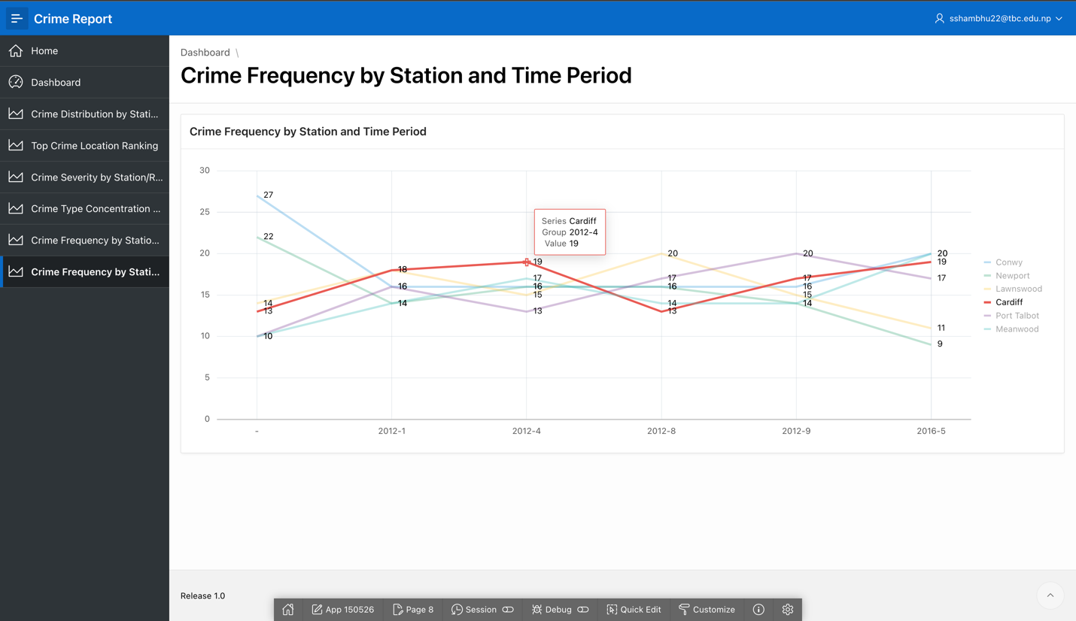

**Analysis**

It gives out the crime figures for each police station by the period of time to show change in the crime trend of different months or years. For instance:

Conwy remains to be the most affected by crime with other months such as 2016-5 (20 crimes), 2012-1 and 2012-9 being worst affected.

The figure for Newport now shows a high number of crimes initially, there is a constant stream averaging over twenty-two crimes and constant activity through 2012.

Comparing Lawnswood to Port Talbot, the numbers of crime instances differ from one year to the other and one month to the other; there were years such as 2012-8 and 2016-5 that depicted high crime rates.

Slightly differently, Cardiff does indicate a broadly cyclical crime trend: the years 2012-4 and 2016-5 experienced particular waves of criminality.

The data also implies that there is possibility that some months or some years detected more crimes across several stations thereby make the rate to be higher due to external factors, seasonal variations or occasions.

**Synopsis**

This analysis shows the fluctuation of crime rates for each police stations although Conwy, Newport and Cardiff remained to have higher crime rate in some periods. Conwy and Meanwood specifically demonstrate high crime levels in early 2016 and mid-2012, whereas Lawnswood and Port Talbot witnesses oscillative movements. Fluctuations in crime could illustrate regional behavioural patterns of people which would signal that more emphasis may be required in such a region at certain periods during the year. The data should be used to find out more about the causes of crime peaks and would be useful for directing the resources to police depending on which time of day[, night] peak crime is.

## **Tableau**

### **Dashboard**

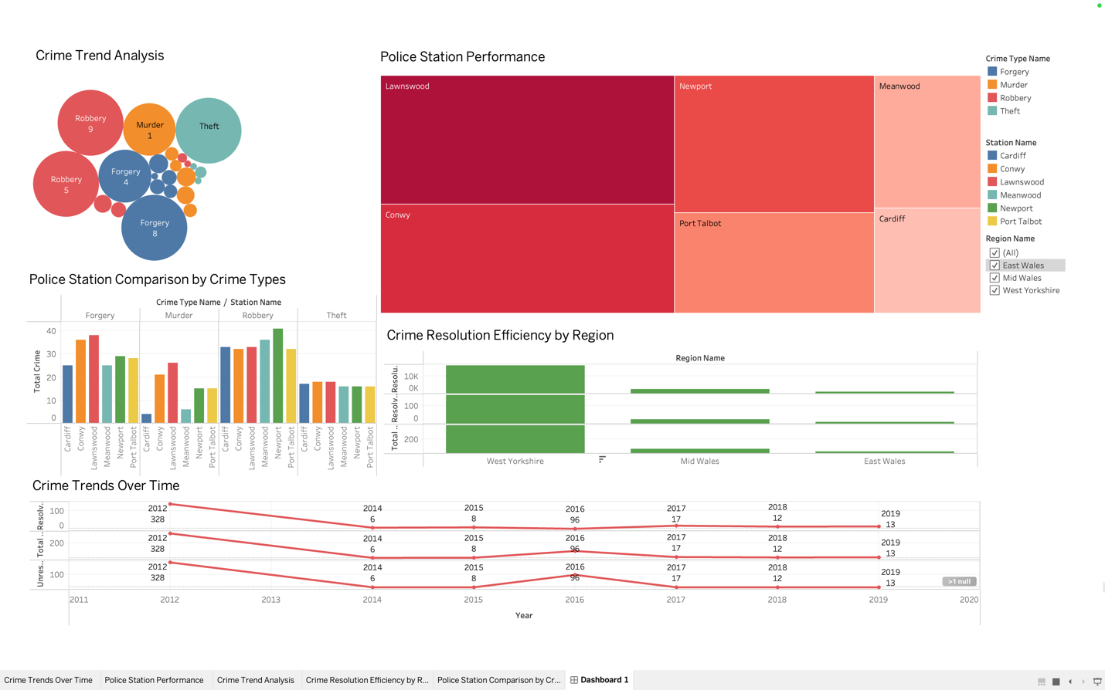

### **Police Station Comparison by Crime Types**

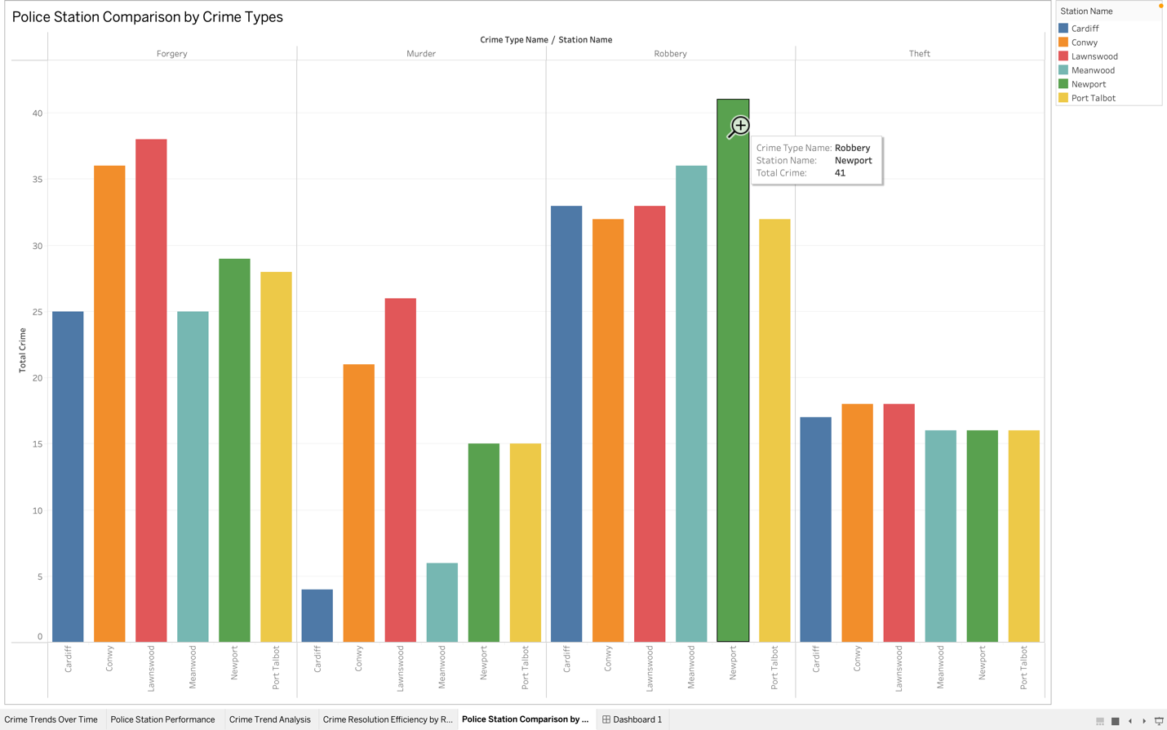

**Analysis**

The bar chart compares crime types across different police stations, showing the distribution of crimes in each station. Robbery appears as the most prevalent crime type, with Newport having the highest total at 41 robberies, followed by Cardiff and Lawnswood, each with 33 robberies. Meanwood reports 36 robberies, while Conwy and Port Talbot have slightly lower counts at 32 robberies each. Forgery is another significant crime type, with Lawnswood recording the highest at 38 cases, followed by Conwy with 36 cases, and Port Talbot with 28 cases. Murder is less frequent overall, with Lawnswood having the highest total at 26 murders, followed by Conwy with 21, and Newport, Meanwood, and Port Talbot, each having a lower count of 15 to 6 murders. Theft shows relatively even distribution across the stations, with Cardiff, Conwy, Lawnswood, and Newport reporting 16 to 18 thefts, while Meanwood and Port Talbot have 16 thefts each.

This data reveals that Robbery is the most prominent crime type across most stations, particularly in Newport. Forgery is also significant, especially in Lawnswood and Conwy. Murder and Theft, while notable, are less frequent overall but still contribute to the crime profile in each station.

**Synopsis**

The analysis of the Police Station Comparison by Crime Types shows that Robbery is the most frequently reported crime, especially in Newport, which has the highest count. Forgery follows closely, with Lawnswood and Conwy reporting the most cases. While Murder and Theft are less common overall, they still show notable totals in certain stations. Lawnswood stands out for both Forgery and Murder, while Newport has the highest rate of Robbery. To optimize crime reduction efforts, police resources could be focused on stations with higher incidences of Robbery, such as Newport, and Forgery, such as Lawnswood. Additionally, targeted interventions could be developed for Murder prevention, particularly in stations like Lawnswood and Conwy. Understanding these patterns can help refine policing strategies to address the specific crime types that are most prevalent in each area.

### **Crime Resolution Efficiency by Region**

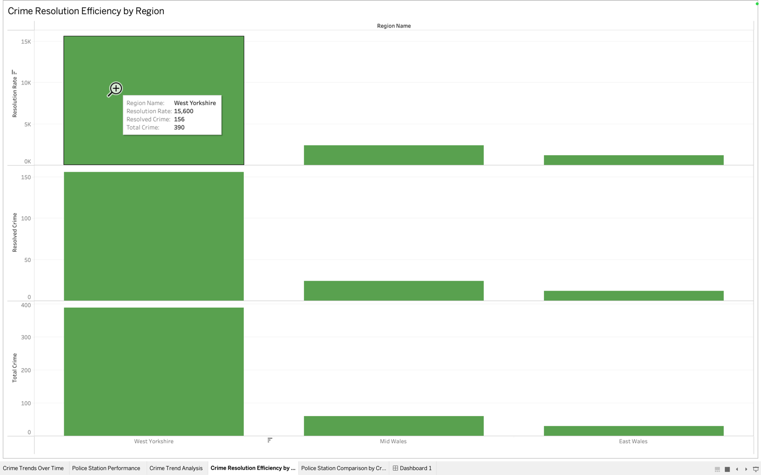

**Analysis**

The bar chart shows how efficiently crimes are being resolved in three regions. East Wales has resolved 12 out of 30 crimes, with a 40% resolution rate. Mid Wales has resolved 24 out of 60 crimes, also with a 40% resolution rate. West Yorkshire has the highest total crime count, resolving 156 out of 390 crimes, which also results in a 40% resolution rate. While the number of crimes varies across regions, the resolution rate is the same in all three, at 40%.

**Synopsis**

The data shows that all regions—East Wales, Mid Wales, and West Yorkshire—have a 40% resolution rate, meaning they all resolve a similar proportion of crimes. West Yorkshire handles the most crimes, resolving the highest total number of 156 crimes, while East Wales and Mid Wales deal with fewer crimes but maintain the same resolution efficiency. This suggests that while crime volume differs, the effectiveness in resolving crimes is consistent. To improve, regions could look at ways to boost their resolution rates further, especially in areas with higher crime numbers like West Yorkshire.

### **Crime Trend Analysis**

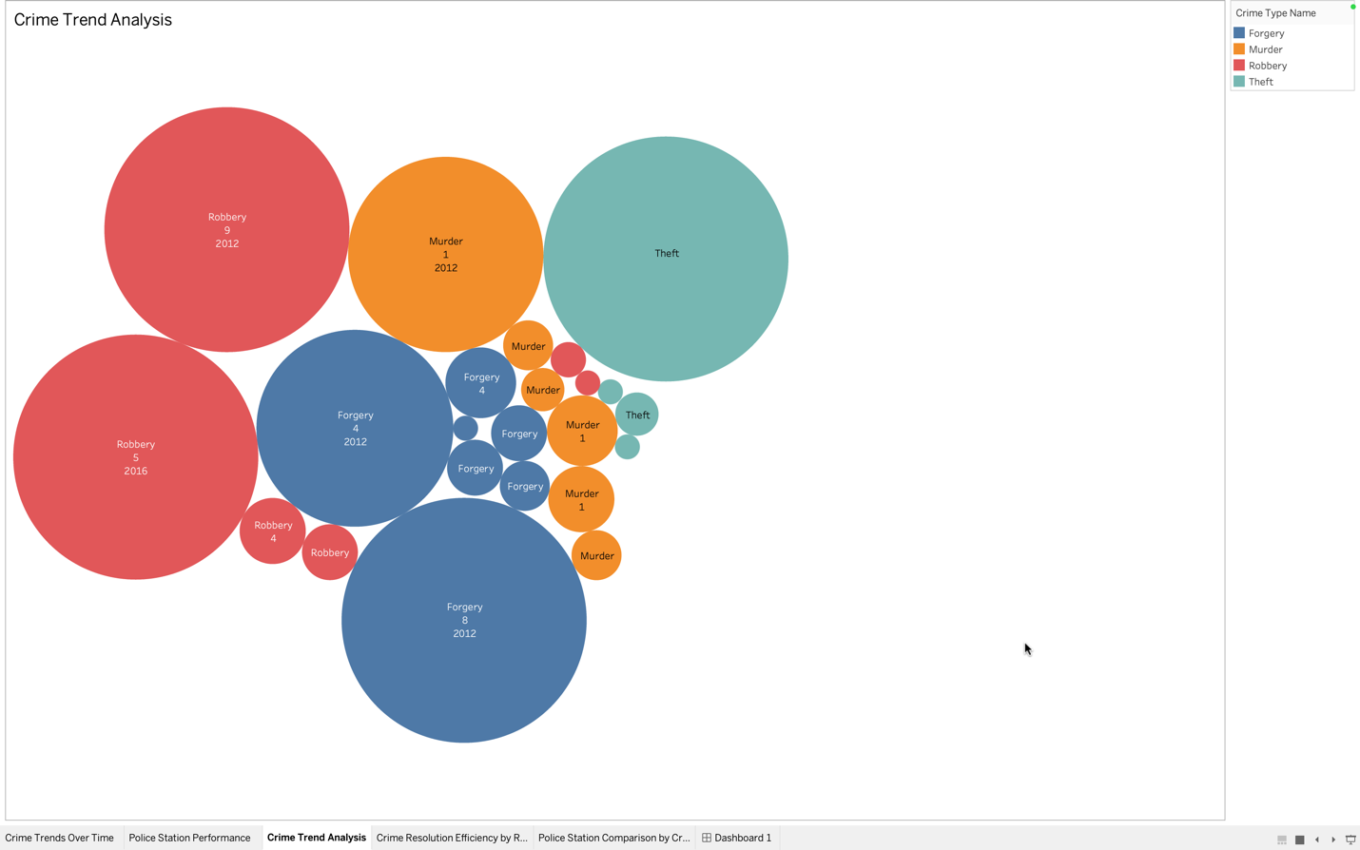

**Analysis**

The chart shows how different types of crime changed over time. Forgery had the highest number of crimes in April 2012 (62 crimes) but dropped to just 1 crime in April 2014, and stayed low in later years. Murder peaked in January 2012 with 61 crimes, but then dropped to very low numbers in the following years. Robbery had two major spikes: one in 2012 and another in 2016. Theft also showed some crimes, with the highest being 96 crimes in 2012, but fewer in other years.

Overall, some crimes, like Forgery and Robbery, had big jumps in certain years, while Murder and Theft had lower or steady numbers over time.

**Synopsis**

From the chart, we see that Forgery had a sharp drop after 2012, Murder peaked in 2012 and then decreased, and Robbery saw two big increases in 2012 and 2016. Theft had a small number of crimes, mostly in 2012. The trends show that crime numbers change from year to year. To address these trends, it could be helpful to look at why certain years, like 2012, had so many crimes and find ways to prevent similar spikes in the future.

### **Crime Trends Over Time**

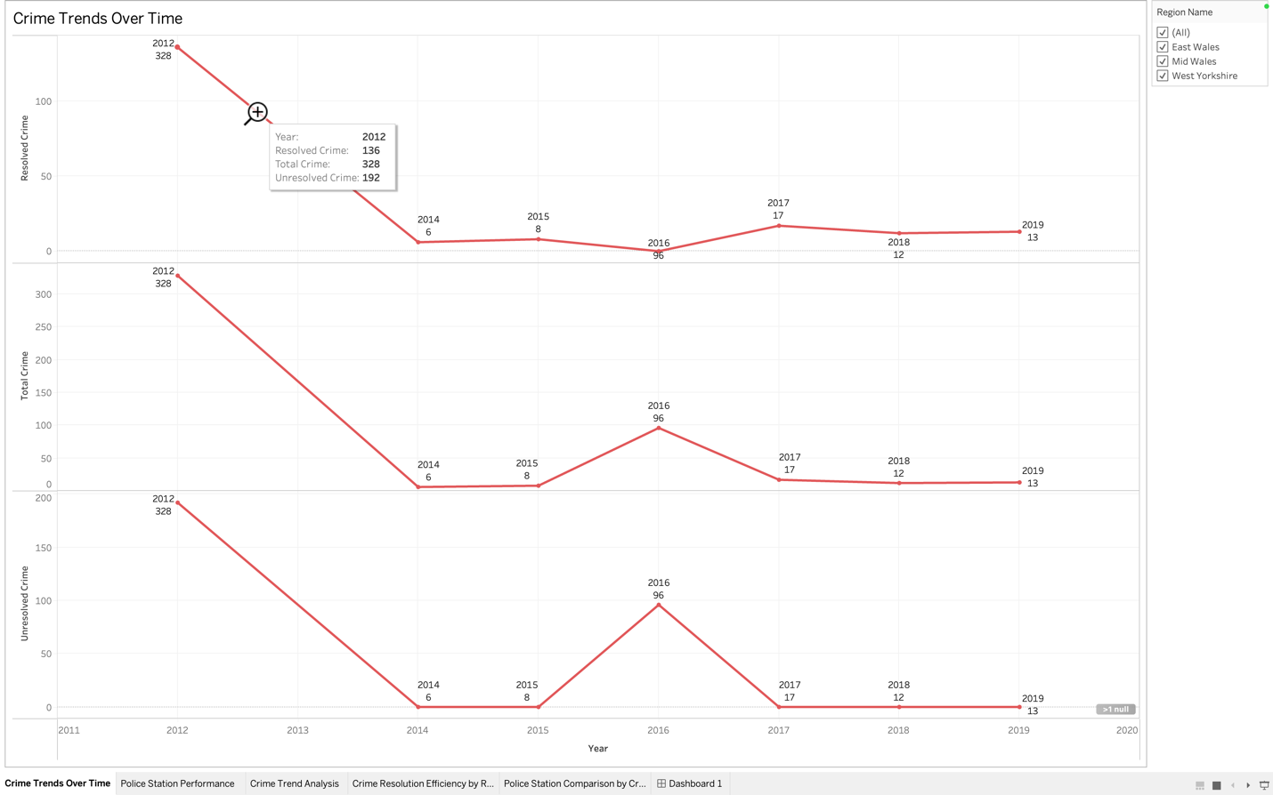

**Analysis**

The line chart shows how crime numbers have changed over the years. In 2012, there were 328 total crimes, with 136 resolved and 192 unresolved. After that, the number of crimes dropped significantly. In 2014, 2015, 2017, 2018, and 2019, there were only a few total crimes, with all being resolved (no unresolved crimes). However, in 2016, the number of crimes rose again to 96, but none were resolved, resulting in all being unresolved.

Overall, we can see a major drop in crime after 2012, with a few isolated incidents in later years, all of which were resolved. 2016 stands out with a high number of unresolved crimes.

**Synopsis**

The data shows that crime numbers were high in 2012 but decreased sharply in the following years. While 2014, 2015, 2017, 2018, and 2019 had very few crimes, 2016 had a spike in unresolved crimes, which may require further investigation. The overall trend suggests that crime has been significantly reduced since 2012, with most crimes being resolved in recent years. However, the spike in 2016 indicates that additional focus might be needed during periods of increased crime.

### **Police Station Performance**

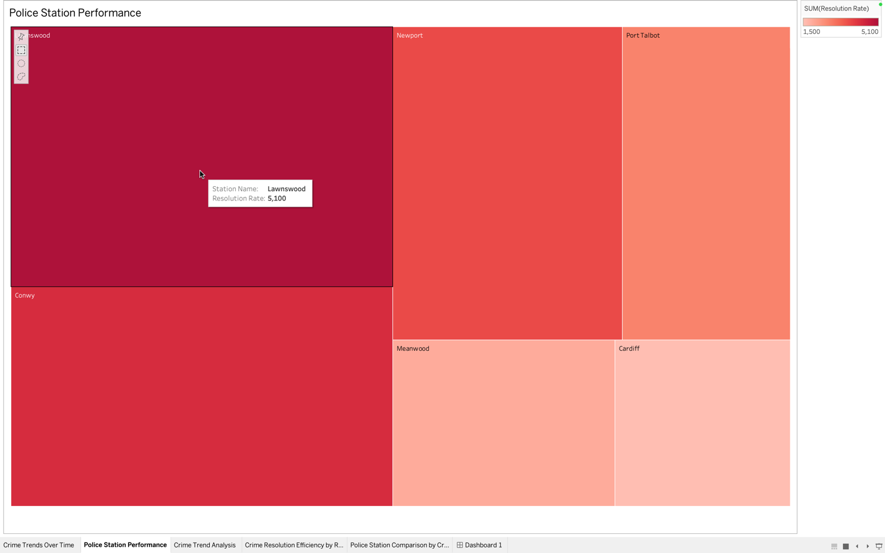

**Analysis**

The treemap shows the resolution rate for each police station. Lawnswood has the highest resolution rate with 5,100, followed by Conwy with 4,300, and Newport with 3,700. Port Talbot comes next with a resolution rate of 2,700, while Meanwood has a rate of 1,900, and Cardiff has the lowest resolution rate at 1,500.

The size of each box in the treemap corresponds to the resolution rate, making it easy to see which stations have the highest and lowest resolution rates. Lawnswood stands out with the highest resolution rate, while Cardiff has the smallest, suggesting a possible area for improvement.

**Synopsis**

The treemap clearly shows that Lawnswood is performing the best in terms of resolution rate, with 5,100 crimes resolved. Conwy and Newport are also performing well, while Cardiff has the lowest resolution rate of 1,500. This suggests that Cardiff may need additional support or strategies to improve its resolution rate. By focusing on improving areas with lower resolution rates, such as Cardiff and Meanwood, the overall performance of the police stations could be enhanced.

## **EXCEL Report**

### **Dashboard**

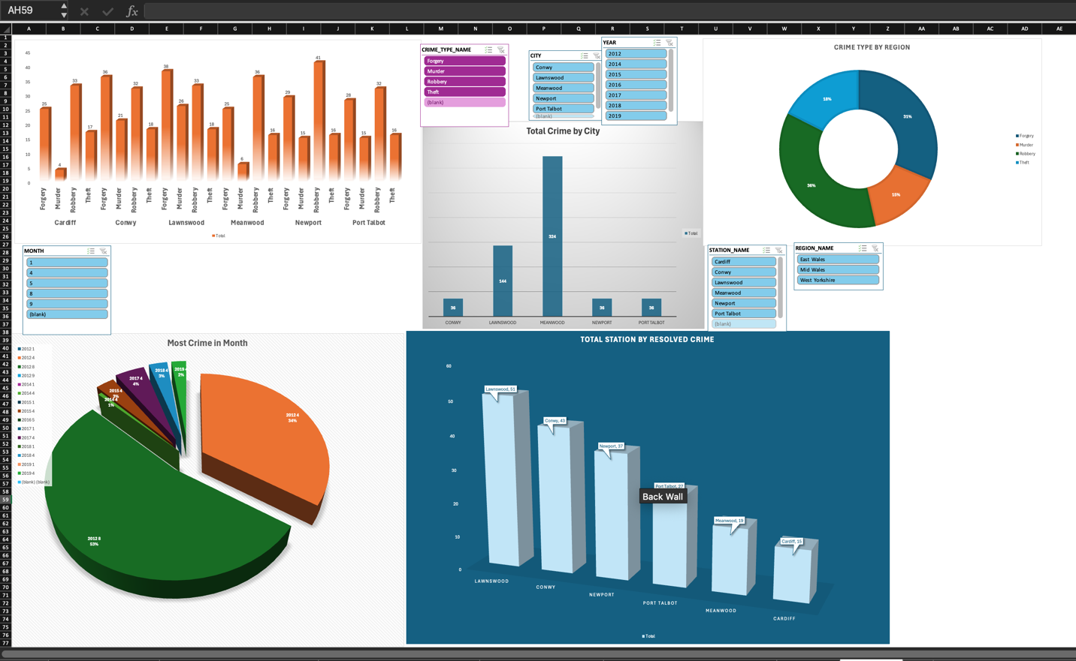

### **Total Station by Resolved Crime**

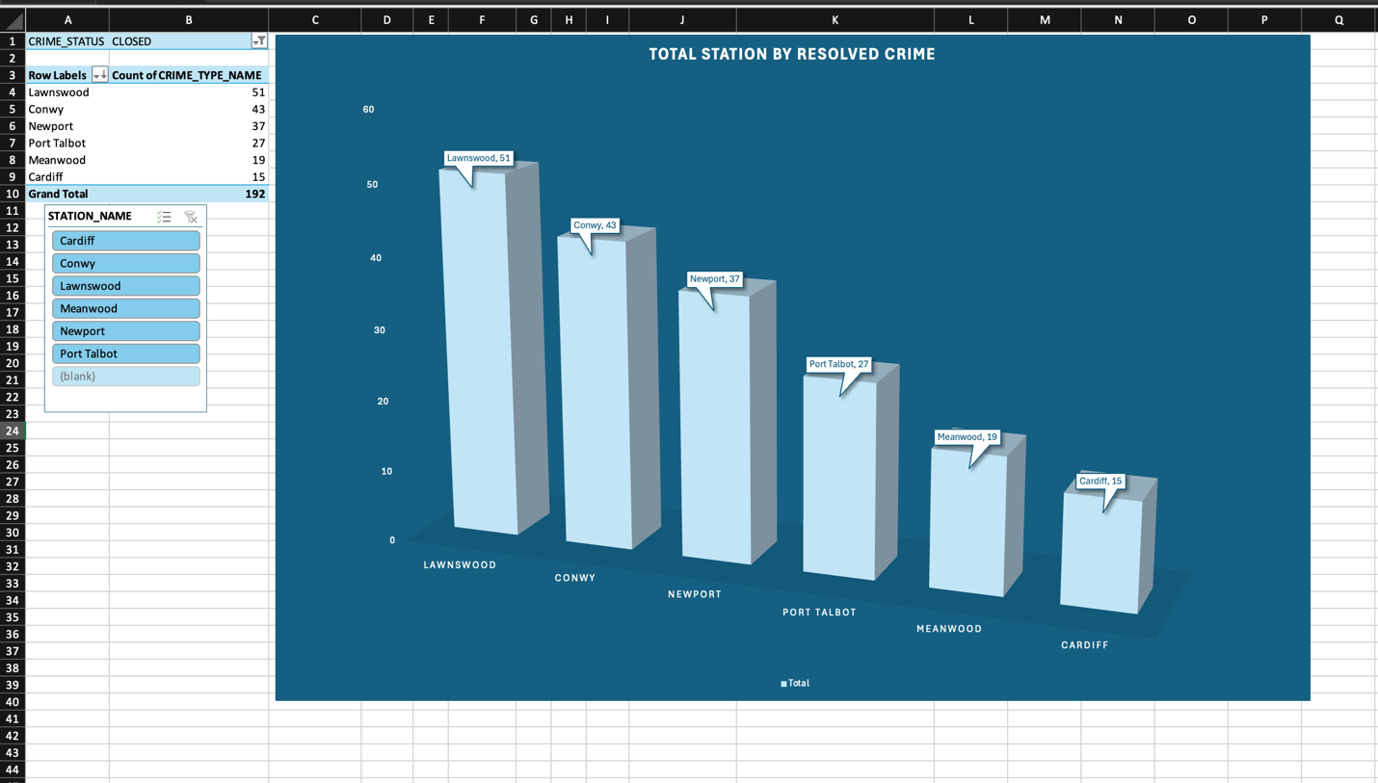

**Analysis**

This is the number of solved (or “CLOSED”) cases by stations. Analyzing the tables and various metrics we are able to identify that the Lawnswood station has 51 solved crimes and the Conwy – 43 solved crimes. These stations are performing well as far as dealing and solving crime-related cases are concerned. Other stations such as newport and port talbot have also been able to ‘solve’ 37 and 27 cases respectively regarded by many as good schemes but not as effective as the above station.. In contrast, there are 19 resolved crimes in Meanwood and 15 in Cardiff. This could means that these stations are facing challenges such as reports of crimes are reducing or other cases are hard to solve. Altogether all the stations have dealt with 192 crimes.

This is well illustrated by the bar chart where the bar showing Lawnswood is the highest because it solves most of the crimes while the bar for Cardiff is the smallest in this case because it solves the least number of crimes.

**Synopsis**

Thus, Lawnswood and Conwy are effectively solving the crimes, although Cardiff has the lowest rate produced. This could be due to one of the several factors including; there are less reported crimes, there are problems in solving the cases. It will be insightful to determine how well-running stations function and attempt to replicate healthier practices in stations including Cardiff. Nevertheless, it would appear that knowing the kind of crimes being solved at each passing station might help in devising a more effective way of handling the issue of crime solution across all the stations. In that way the overall crime resolution, which is maybe currently lower than needed in some areas, might be raised and the result would be positively affected.

### **Crime type by region**

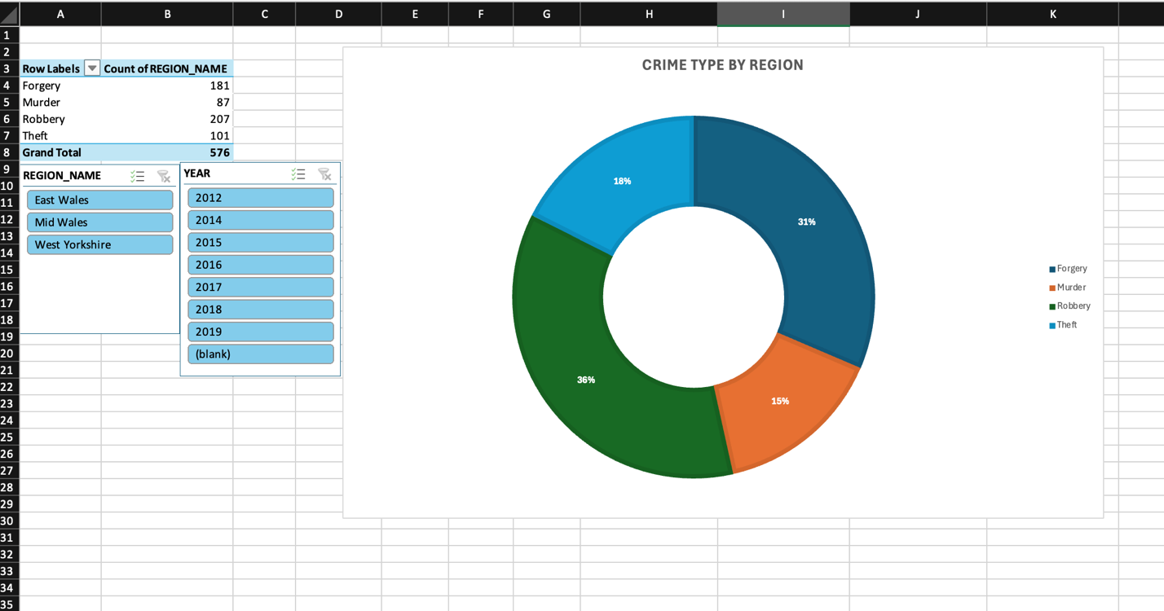

**Analysis**

The doughnut chart shows the breakup of various types of crime in the region. Raising the highest tally with 207 incidences, Robbery cobbles the highest percentage of the total crimes from the dataset. One is fraud which is slightly lower with 181 cases meaning that it is also a major problem in the region. Robbery has 101 cases making them another recognizable crime type, but less significant than theft and forgery. Crime recorded 87 cases in murder, which it is comparatively low but still remains a social vice. All in all, the dataset amounts to 576 solved cases where robbery and forgery are the most reported crime types. This distribution indicates that further measures to prevent robbery and forgery could be taken as these two types of crime are the most common in the southern region.

**Synopsis**

As highlighted in this paper, this analysis shows that Robbery and Forgery are the most prevalent crimes in the region with Robbery crimes being the most dominant. Compared to other crimes the above have been mentioned to be less frequent but are among the crimes that most people have been recorded to have fallen victim to. These trends are shown in the doughnut chart emphasizing the fact that robbery and forgery are the most common types of a crime. In order to enhance crime prevention activities, attention to the issue of robbery and forgery may play a large role. Furthermore, it may be possible to get to the bottom of factors that lead to stealing as well as murder so that the right approach is implemented. If these crime types were categorized further, law enforcement meant authorities would be in a position to direct their efforts where the problem needed fixing most in the region.

### **Repeated offence by station**

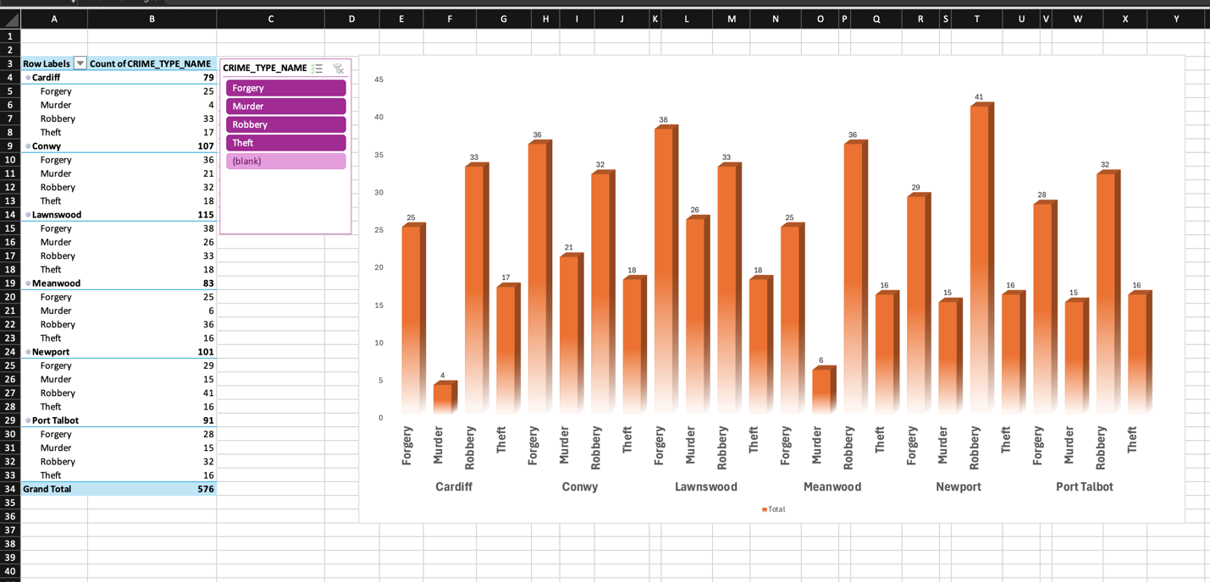

**Analysis**

The bar chart gives information on how frequent crimes have been repeated across sections of different stations. Of all the stations, Lawnswood identified the highest number of 115 crimes of which Forgery accounted for 38 crimes and Robbery accounted for 33 crimes, Murders stood at 26 while Theft crime recorded only 18. This show that Lawnswood is managing multiple cases of repeated offences for instance in forgery and robbery. Conwy is close to this figure with 107 crimes, Forgery as the most common type of crime with 36 crimes followed by Murder (21 crimes) and Robbery with 32 crimes similarly to Lawnswood but with a lot lesser number of Murder. The fresh crimes recorded at Newport and Port Talbot stations are also high; Newport having committed 101 crimes, which included robberies 41, and 91 at Port Talbot of which Forgery 28 and Robbery 32. We pursue this by comparing Meanwood’s total of 83 criminal activities, which is dominated by the 36 Robberies, with the Forgery rate of 25 and Murder rate of 6. Cardiff, which revealed the overall minimum of 79 crimes, also has 25 Forgery and 33 Robbery crimes. Altogether, the findings suggested that Forgery and Robbery are the most frequently repeated crimes committed at the various stations and that Murder, although less common, is committed in fairly different numbers.

**Synopsis**

As can be seen from the table and graphs, Lawnswood, Conwy and Newport stations which recorded high crime rates suffered a lot of Forgery and Robbery crimes, which are considered to be repeated crimes. Newport has the highest trend for robberies while Lawnswood has the highest overall total with crimes focused on forgery and robbery. , although having a number of total crime rates below other cities, has significant problems with robberies and forgeries. Fig 5 above shows that Forgery and Robbery are r antique across most stations: these crime types should therefore be targeted. Presumably, knowledge and identification of such two crimes will be helpful in concentrating efforts of crime prevention programs for the improvement of its effectiveness. Also, knowledge of the factors which contribute to Robbery could be useful in determining particular issues faced by Newport and Meanwood stations. Since certain crime types are committed more frequently, authorities can direct resources and efforts on how to fight crime more efficiently all across the area.

### **Most Crime in Month**

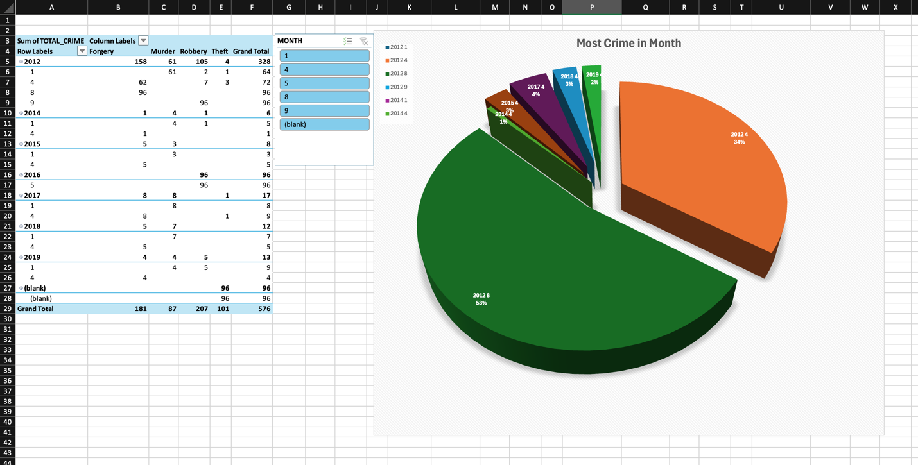

**Analysis**

The pivot table shows the crime distribution based on the year and month and the fluctuations in the crime counts of Forgery, Murder, Robbery, and Theft. The highest crime activity was recorded in the year 2012, out of which forgery stood as the most common crime followed by August with ninety six crimes recorded in that month. There was a high number of murders in January ((61)), while Robbery was present all year long though reached its highest in the first month ((105)). Goot and McAllister also noted that theft, albeit lower in rate than all other crimes, substantially occurred in the month of August to slightly above the midpoint. The trend shows that even though 2012 had high total crime numbers, years like 2014, 2015 and 2017 recorded low total crime rates of most of the crimes listed above. On this note, it is worth to notice that in 2017 only Robbery had a mild increase again, with January recording 8 crimes.

**Synopsis**

This statistical information indicates a cyclic nature of crimes in the year 2012 and the crimes were prominently higher during January and August and the commonly reported crimes were Forgery and Robbery. Murder had the highest count in the beginning of the year January 2012, but it trend has slightly decreased in the following years. The percentage and number of theft cases stayed significantly reduced throughout the periods with occasional surge. The consolidated crime statistics for 2012 depict a year of high crime incidence and a consecutive decrease in the succeeding years indicating that almost all the crime rates has reduced after the year 2012. understood from the crime activity in 2012 that intervention should be made targets during months of January and August.

### **Total Crime by City**

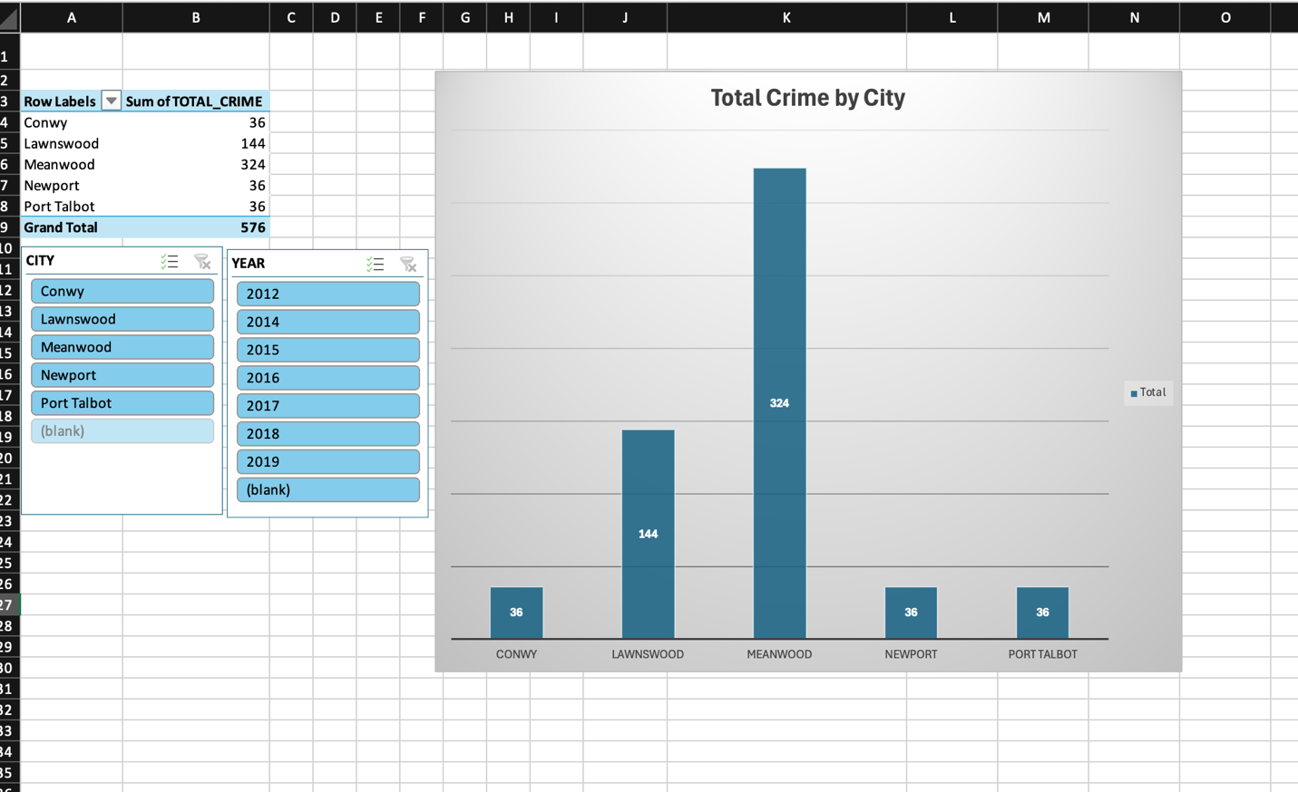

**Analysis**

The bar chart illustrates the total number of crimes reported across different cities, with significant variation in crime totals. Meanwood stands out with the highest total of 324 crimes, indicating it is the city with the most significant crime activity. In contrast, Lawnswood follows with 144 crimes, marking it as a major contributor to the overall crime count, though significantly lower than Meanwood. Both Conwy, Newport, and Port Talbot report much lower totals, each with 36 crimes, representing the cities with the least crime activity in the dataset. The Grand Total of 576 crimes reflects the overall crime count across all cities.

The bar chart visually shows the stark differences between Meanwood and the other cities, with Meanwood having the longest bar, while Conwy, Newport, and Port Talbot have much shorter bars, highlighting their relatively low crime totals.

**Synopsis**

The analysis shows that Meanwood has the highest crime total at 324, making it the city with the most significant crime issues in the region. Lawnswood follows with 144 crimes, also contributing significantly to the total crime count. In contrast, Conwy, Newport, and Port Talbot each report 36 crimes, indicating that these cities are experiencing much lower levels of crime compared to Meanwood and Lawnswood. The total crime figure of 576 across all cities suggests that while some cities, like Meanwood, have high crime rates, others maintain relatively low crime activity. To address the disparities in crime across cities, it may be helpful to focus resources and interventions on cities like Meanwood and Lawnswood, while continuing to monitor and maintain crime prevention efforts in cities with lower crime counts, like Conwy and Port Talbot.

# **Task – 2**

# **Data Maintenance**

Data Maintenance is defined as the techniques that are adopted for managing and preserving those data that are very vital in business processes with time. It can be defined as a process of maintaining accuracy, completeness, consistency, and integrity of both manual and automated information systems data throughout their life cycle. Data maintenance can include operations such as data scrubbing, data refreshing, data requantization, checking and correcting of possible data corruption due to changes of systems or in accordance to new regulations as well.

Here’s an overview of its importance:

**1. Improves Data Quality**

* **Accuracy and Consistency:** This is important to maintain the accuracy of the data as it is used to make daily decisions at the health facility. This minimizes the chances of producing inaccurate reports, analysis and decisions within that given period.
* **Data Cleaning:** That is important since it helps to drive out errors such as duplicate values, typographical errors, and data contradictions in a set of data thus increasing the reliability of the data.

**2. Enhances Decision-Making**

* **Better Insights:** Timely and proper archiving allows leaders to make sound decisions based on the data fed to them by professionals.
* **Real-time Information:** Storing data up to date enables the user to have timely information that is very useful in any dynamic business organization.

**3. Comprehensive support of regulating authorities & Regulation of products & services**

* **Data Integrity:** Some maintenance practices are legal as they refer to actual and secure data storage and processing regulations (e.g., GDPR or HIPAA).
* **Auditability:** Maintained data lets auditors assess whether compliance standards are met while the process is less time-consuming for businesses.

**4. Addresses Risks to Operations**

* **Streamlined Processes:** Using clean, structure and updated data in business reduces redundancy in ways such as performing a search on outdated and or inaccurate information.
* **Faster Access:** Better on-employee data management dictates that the relevant data should be easily retrievable and correct/updated when necessary.

**5. Reduces Costs**

* **Prevents Redundancy:** Good data management minimizes the expenditure incurred in archiving large amounts of unutilized or obsolete information.
* **Avoids Risks:** Through data maintenance, wrong data is noticed and changed or erased before it causes harm that could be financially devastating.

**6. Enhances Perception of the Company’s Products**

* **Better Service:** For those businesses that use customer data for instance in CRM systems, keeping the information up to date helps to make quicker responses and target each customer uniquely.
* **Trust and Reputation:** This is why customers always prefer to work with an organization that guarantees privacy and precision of data and information keeping since this helps improve on customer relations.

**7. Supports Data Integration**

* **Data Consistency Across Systems:** Periodic data cleansing results in data being consistent between different systems, such as ERP or CRM, which in turn makes integration work easier.
* **Facilitates Data Merging:** This is especially important when an organization merges with other organizations or when it incorporates new technologies into its business processes since well-maintained data can easily be transferred and used across those new technologies.

**8. Promotes Long-Term Data Value**

* **Sustains Historical Relevance:** Data maintenance keeps data archives that are useful for long-term trend forecasting and business planning.
* **Data Preservation:** Rarely am I faced with the problem of obsolete data, though when it occurs, it is always possible to move the data to a storage area for later use after performing maintenance.

**Key Practices for Effective Data Maintenance:**

1. **Data Cleaning:** Check and rectify any error or inconsistency, like ‘#NA’, duplicate records, or other data format issues.
2. **Data Backup and Recovery:** This means that protecting information requires an effective back up system that will enable quick recovery of lost information.
3. **Regular Updates:** Data should be up to date by inputting data frequently updating records and removing old information.
4. **Monitoring:** In addition, make sure that the quality of incoming data is continuously assessed and detected problems are solved immediately.
5. **Access Control:** It is crucial that the information bearing system or database be viewed and modified only by authorized personnel and that all the security precautions should be observed.

## **Vertical and Horizontal Partitioning**

**Vertical Partitioning:** This is achieved by splitting a table into other tables depending on columns present within a table. For instance, assume a table having many columns while some of the columns are frequently used for query retrieval and others are not. And it also can enhance quantities and assist in data managing since the needed data should be maintained more efficiently.

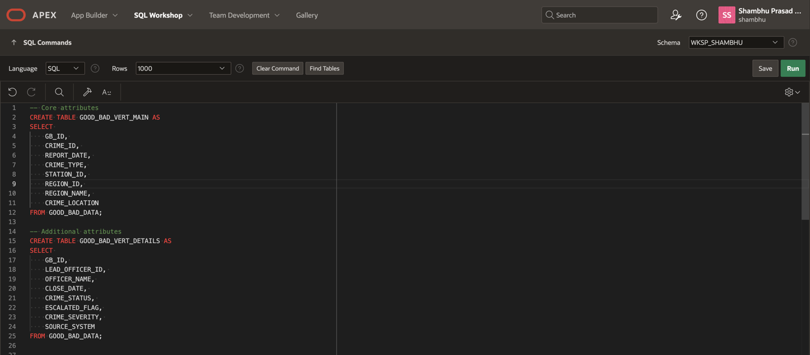

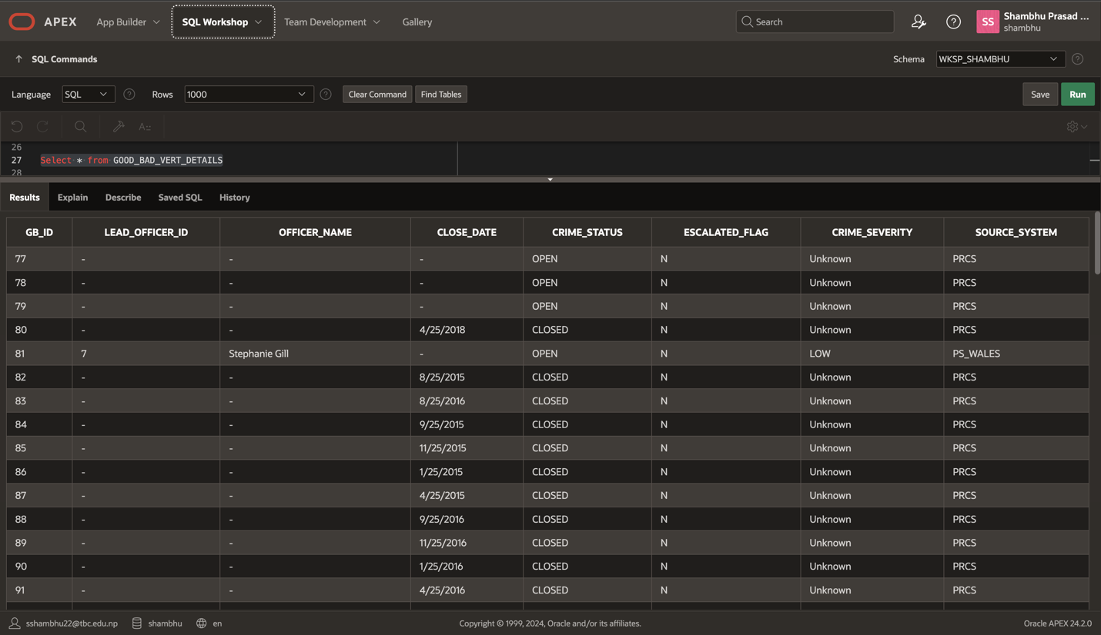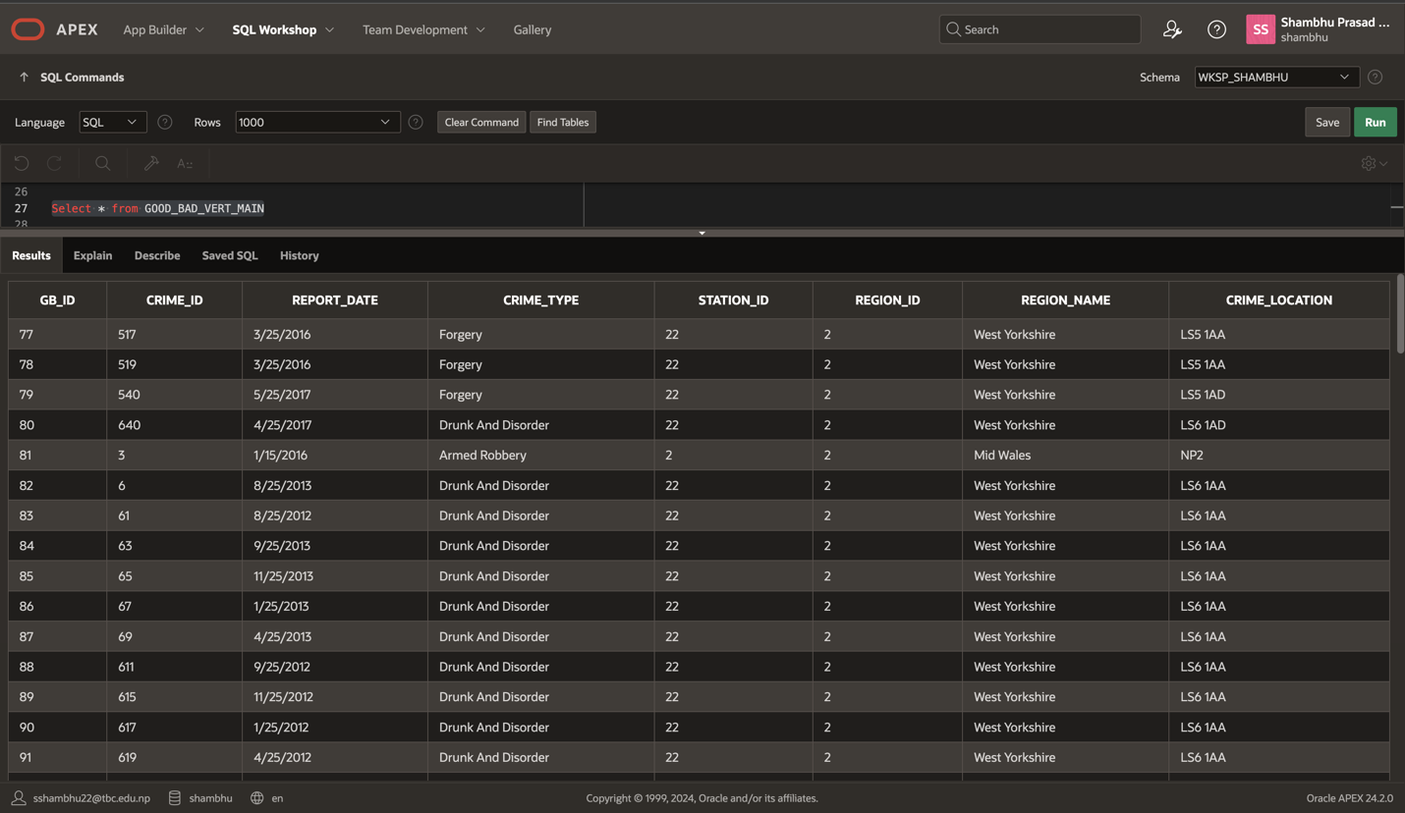

**Horizontal Partitioning:** This involves partitioning of a table by rows, reason being in most cases it is done in an effort to enhance performance. For instance, as to large tables, these can be divided into smaller sub-tables classified by key field criteria such as dates. This assists in data access, enhances the capability of queries as well as decreases the amount of time required in other maintenance processes such as back-ups.

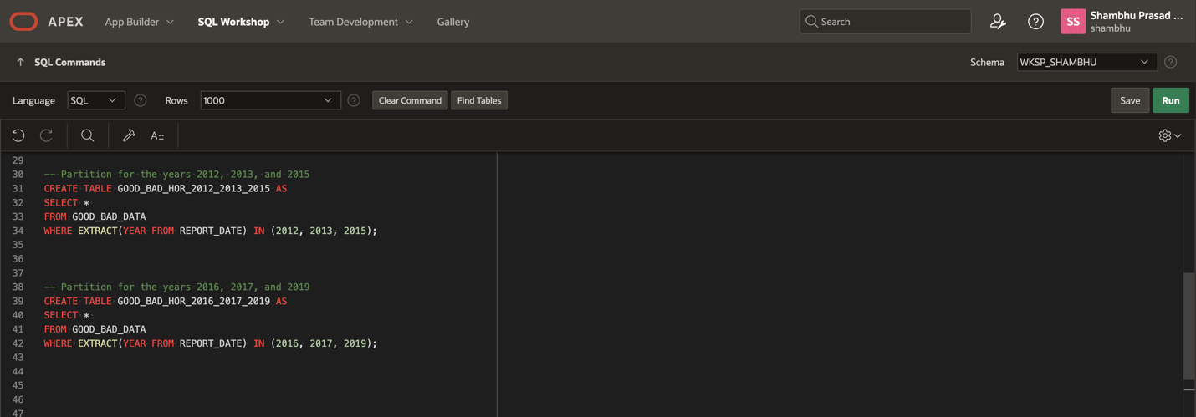

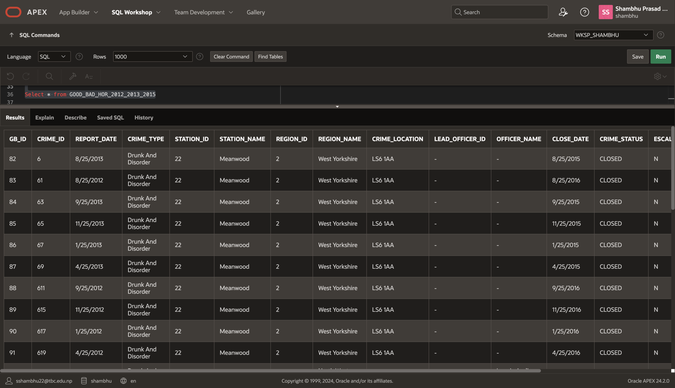

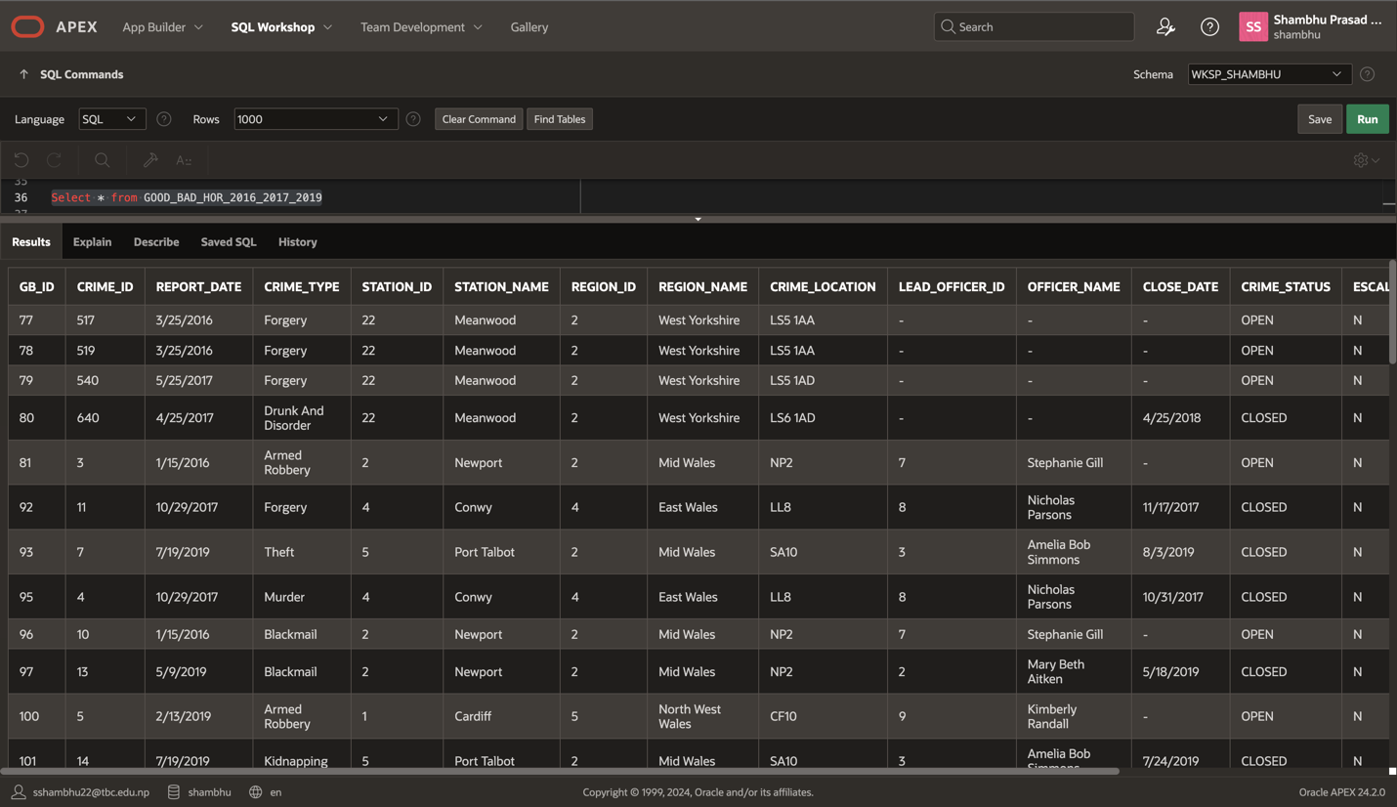

## Slowly Changing Dimensions

Slowly Changing Dimensions (SCDs) are employed as a tool in data warehousing to handle modifications to dimensions, defined as descriptive attributes of business subjects. This is useful to keep a proper history for the document, and to see what the state of the system was in previous moments as well as the current state.

There are several types of SCDs, each with its own approach to handling changes:

### **Type 0: Fixed Dimension**

Description: Data does not change. In this application once a value is assigned it cannot be changed for the corresponding unit.

Use Case: We find usage in situations where progress is not anticipated in the future (i.e., manufacturing date of a product).

### **Type 1: Overwrite**

Description: Modifies the values in the table by replacing the old value in that due by the new one. No history is maintained.

Use Case: Appropriate for change that is not critical and which does not require prior data.

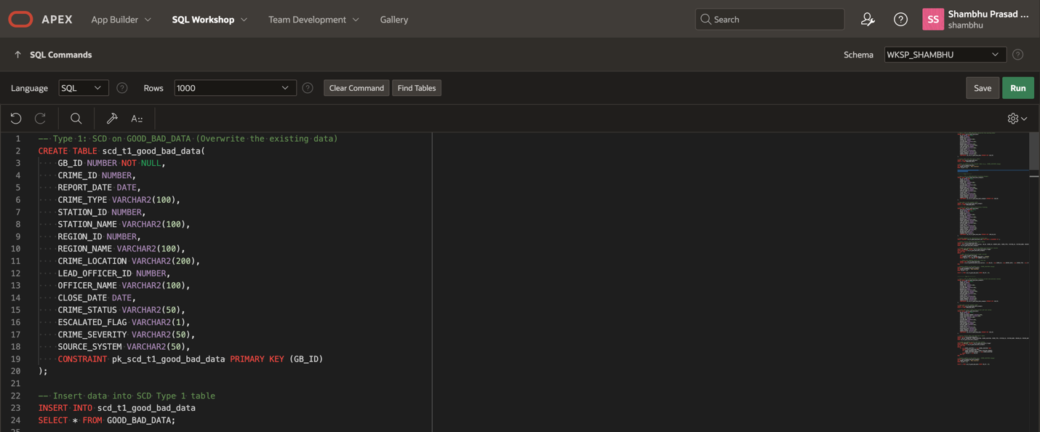

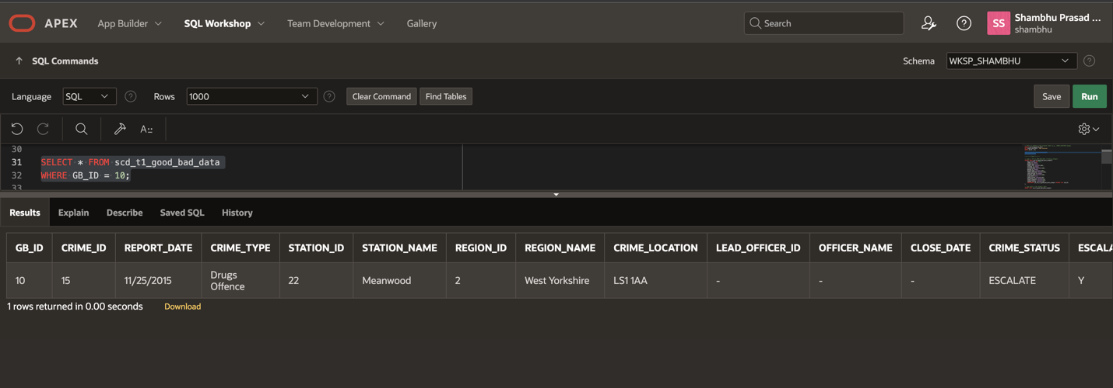

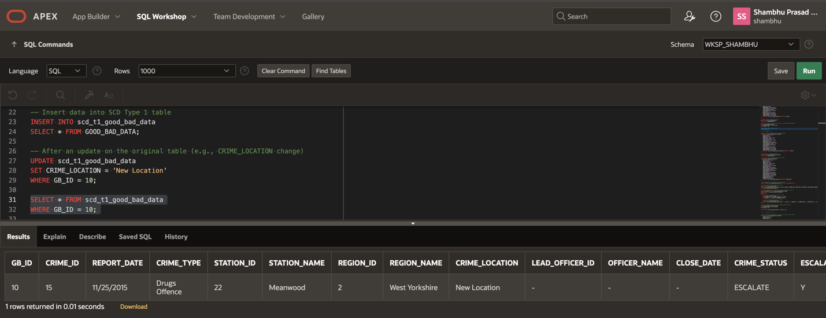

### **Type 2: Add a New Row**

Description: Overall, a new row is created for every change, whilst maintaining the current and previous values available. Usually incorporates use dates or modification numbers in the form of dates.

Use Case: Working best when it is desirable to document the changes in any kind of data over time.

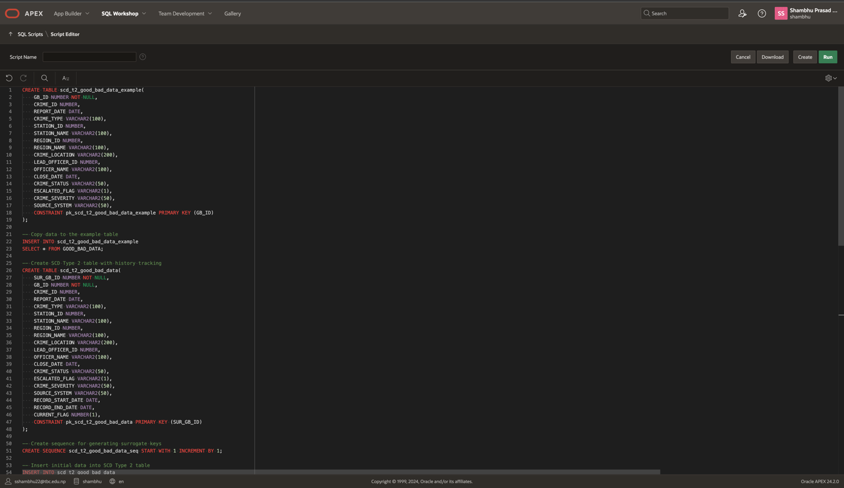

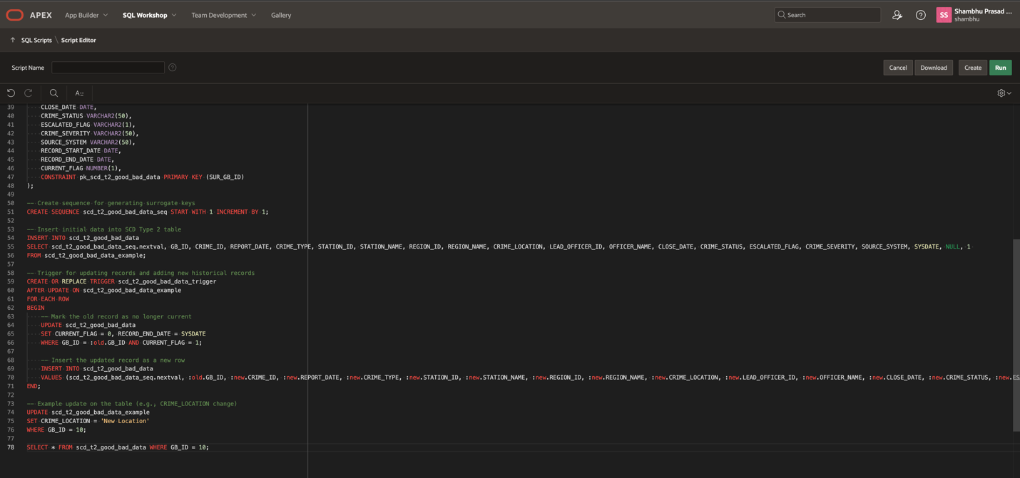

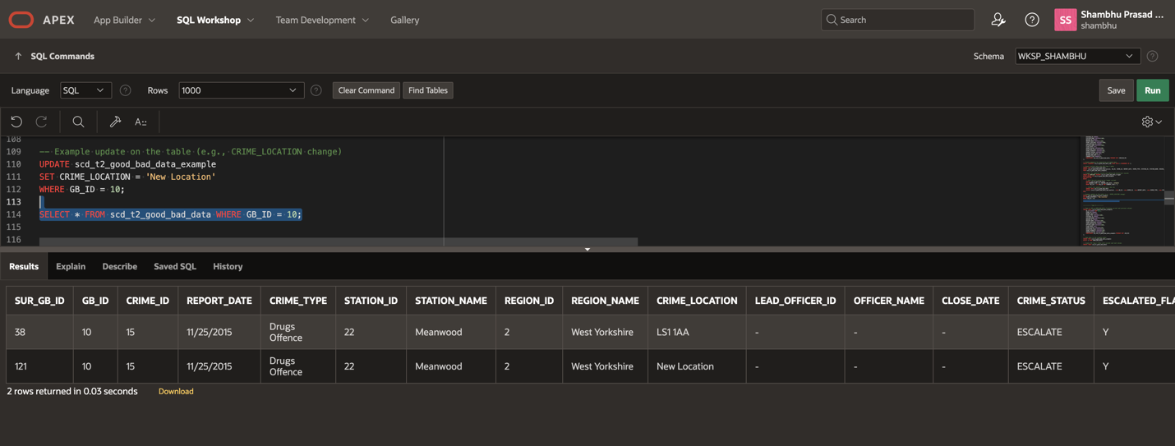

### **Type 3: Add a New Column**

Description: Introduces new columns to store the previous value in addition to current value. It records few past occurrences (al often it records only one or two modifications).

Use Case: Employed when there is a requirement to monitor low history which cannot take rows into an additional number addendum.

**Code**

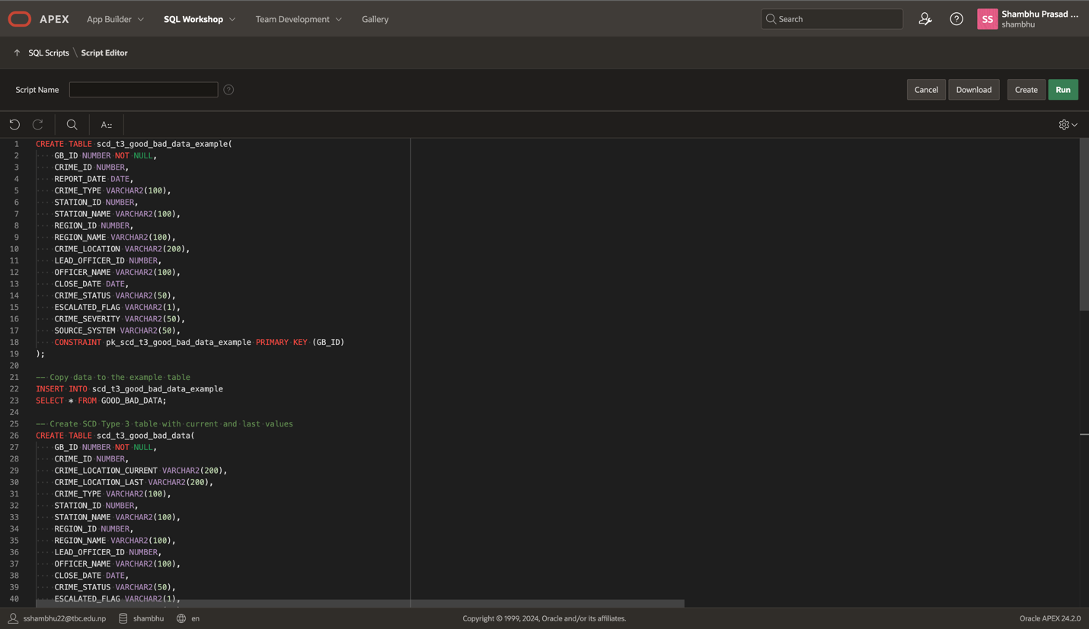

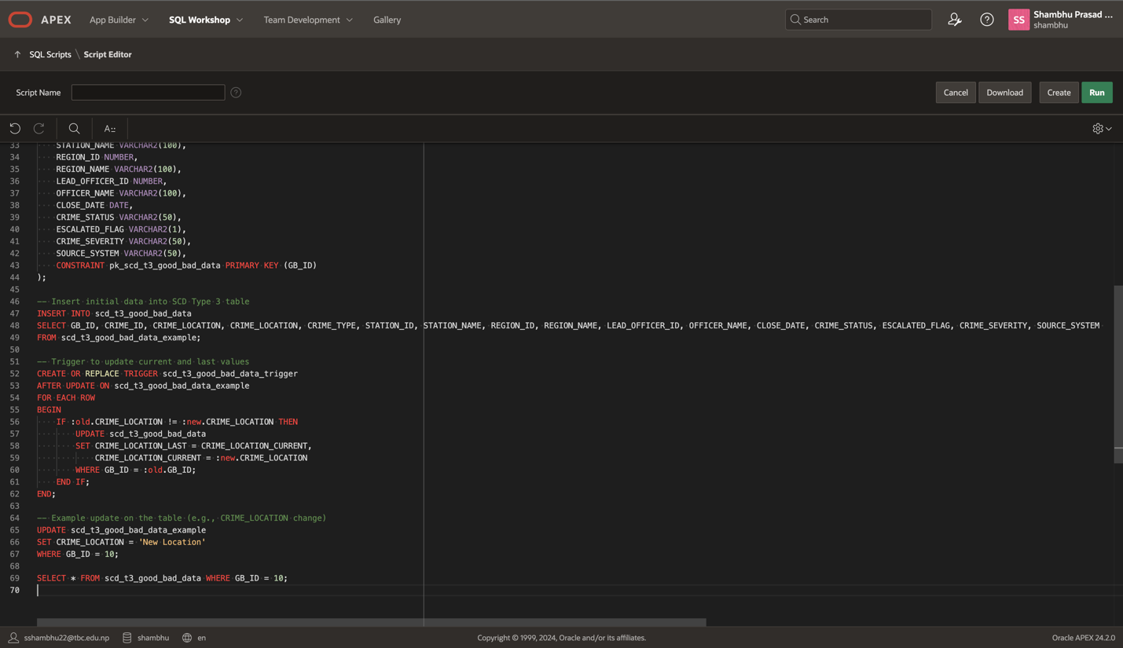

**Result**

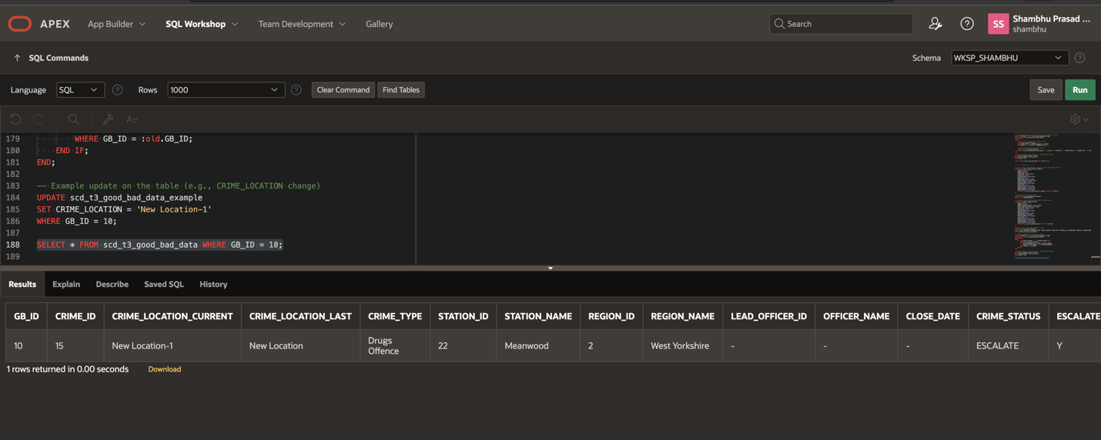

# **Package, Function and Procedure**

## **Transformation Table Package**

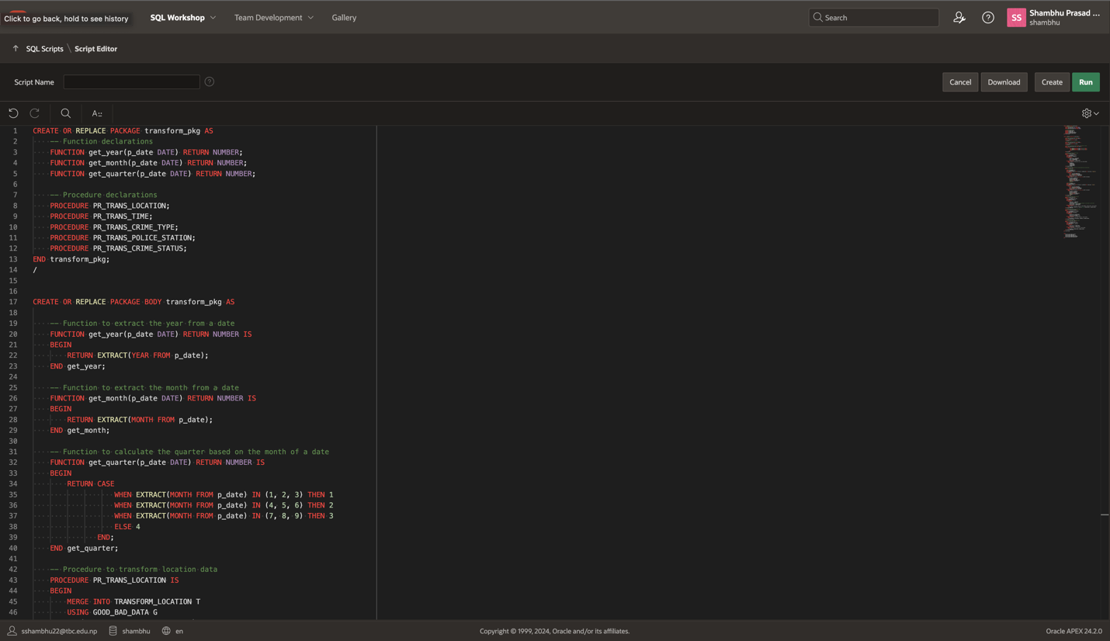

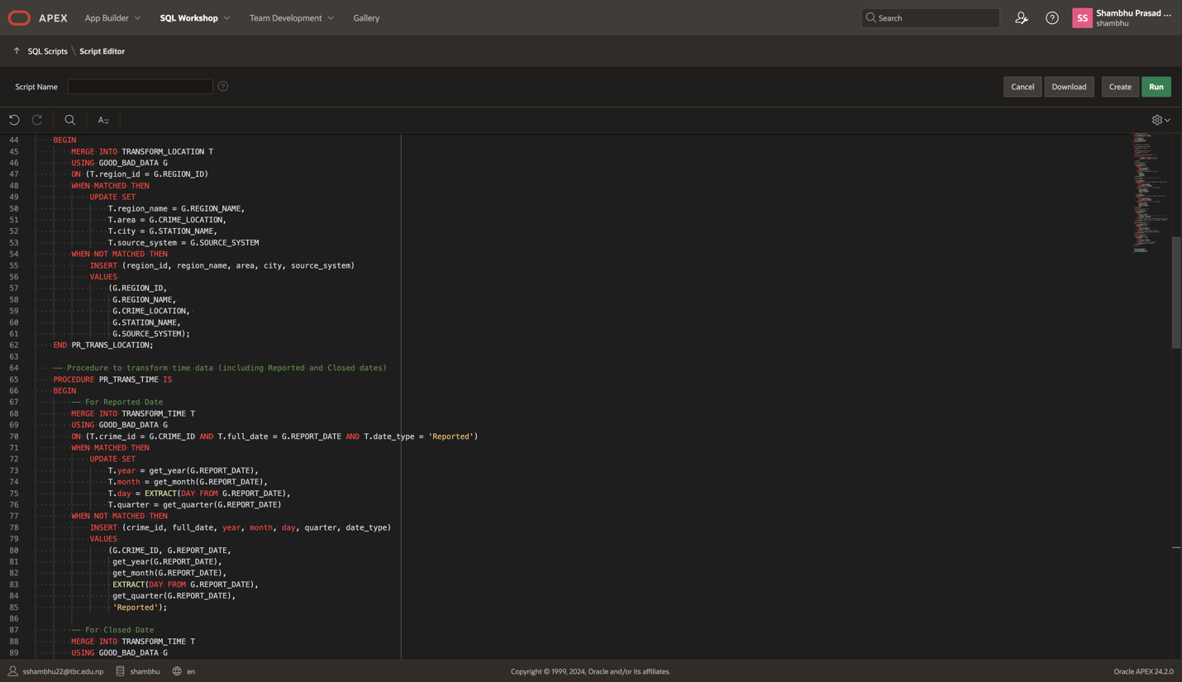

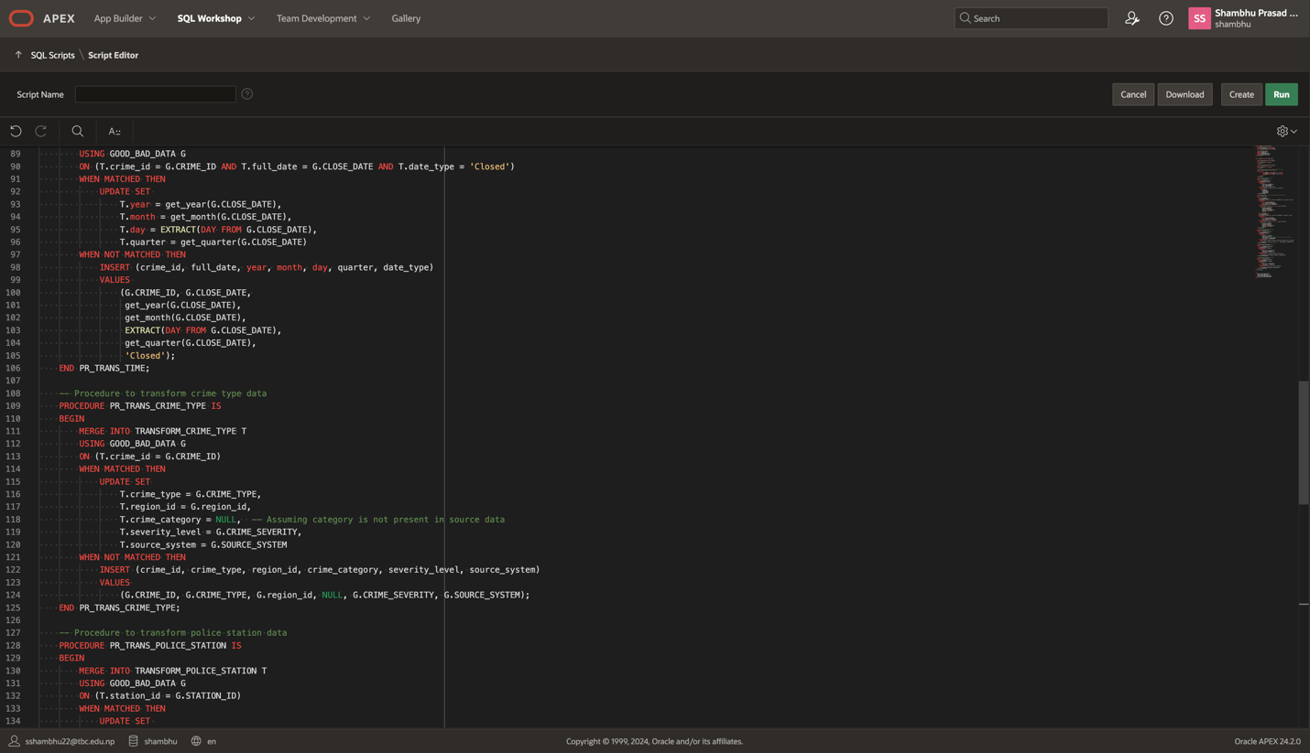

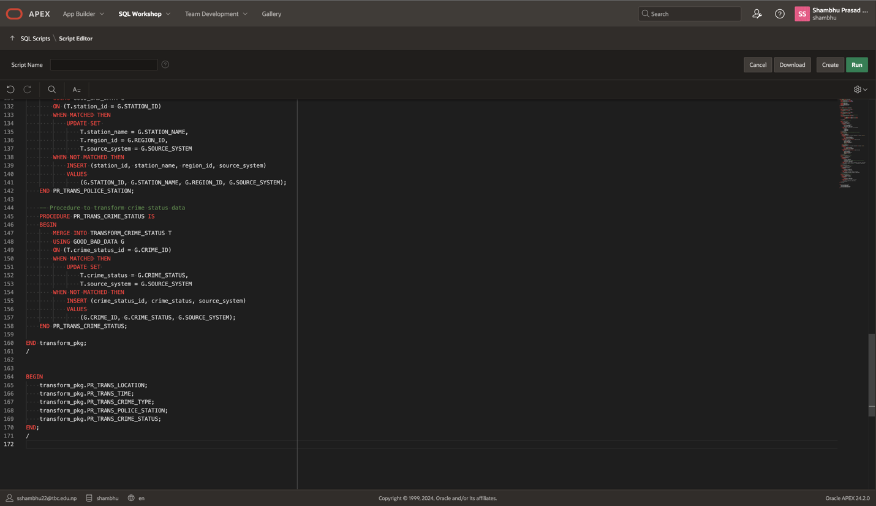

This code is for transforming crime-related data into a more structured format.

**Functions:** Extract year, month, and quarter from dates.

**Procedures:**

* PR_TRANS_LOCATION: Updates or adds location info for crimes.
* PR_TRANS_TIME: Updates or adds time-related info (like report and close dates) for crimes.
* PR_TRANS_CRIME_TYPE: Updates or adds crime type details.
* PR_TRANS_POLICE_STATION: Updates or adds police station details.
* PR_TRANS_CRIME_STATUS: Updates or adds crime status.

It uses a MERGE statement to either update existing records or insert new ones into transformed tables. The code is executed at the end to perform these data transformations.

## **Dim Table Load Data Package**

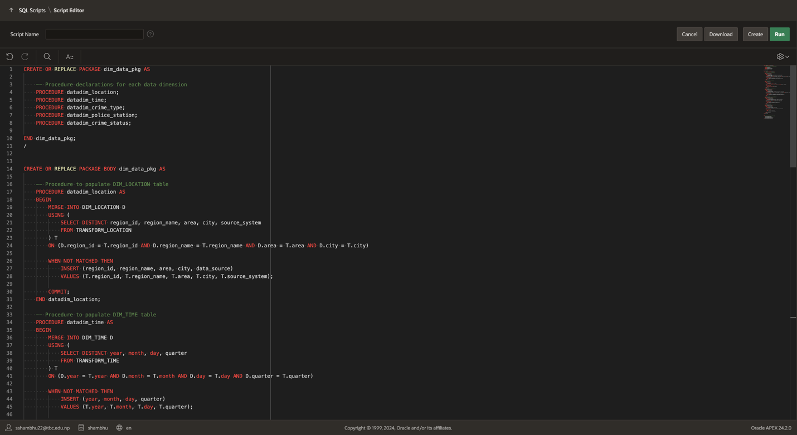

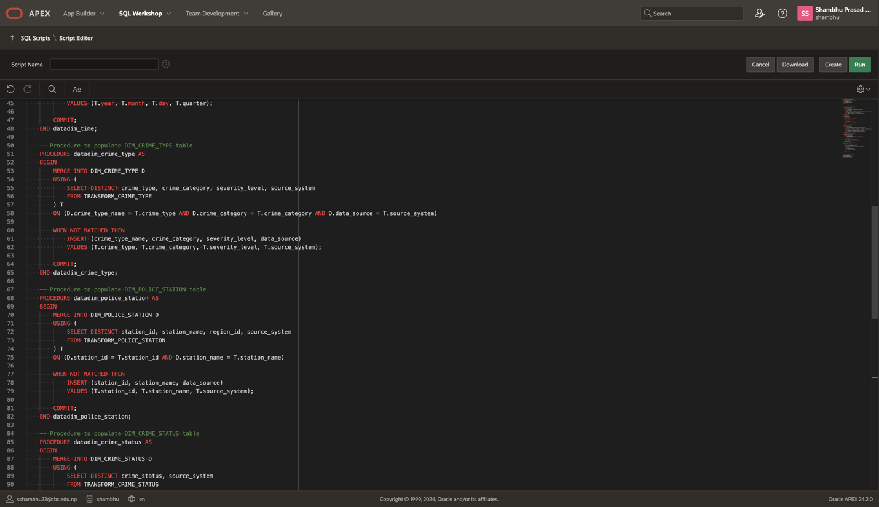

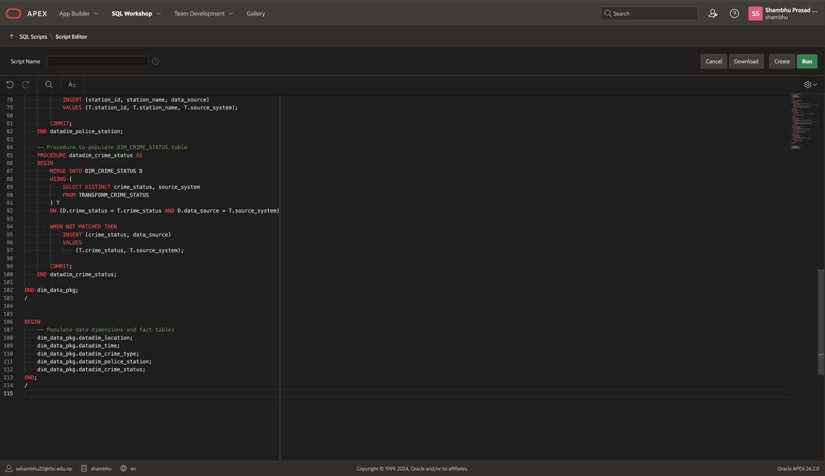

The above code defines a PL/SQL package called dim_data_pkg, which is used to populate **dimension tables** in a data warehouse based on transformed crime data.

**Key Parts:**

1. **Package Declaration:**
   * This part defines the procedures for populating each dimension table.
     + **datadim_location**: Populates the DIM_LOCATION table.
     + **datadim_time**: Populates the DIM_TIME table.
     + **datadim_crime_type**: Populates the DIM_CRIME_TYPE table.
     + **datadim_police_station**: Populates the DIM_POLICE_STATION table.
     + **datadim_crime_status**: Populates the DIM_CRIME_STATUS table.
2. **Package Body:**
   * This section contains the logic for each procedure:
     + **datadim_location**: Merges data from the TRANSFORM_LOCATION table into the DIM_LOCATION table, adding new records if they don't already exist.
     + **datadim_time**: Merges data from the TRANSFORM_TIME table into the DIM_TIME table.
     + **datadim_crime_type**: Merges data from the TRANSFORM_CRIME_TYPE table into the DIM_CRIME_TYPE table.
     + **datadim_police_station**: Merges data from the TRANSFORM_POLICE_STATION table into the DIM_POLICE_STATION table.
     + **datadim_crime_status**: Merges data from the TRANSFORM_CRIME_STATUS table into the DIM_CRIME_STATUS table.
   * **MERGE** is used to either update existing records or insert new ones into each dimension table. The COMMIT ensures that changes are saved.
3. **Main Execution Block:**
   * This block calls all the procedures to populate the dimension tables.

## **Staging Table and cleaning Package, Procedure**

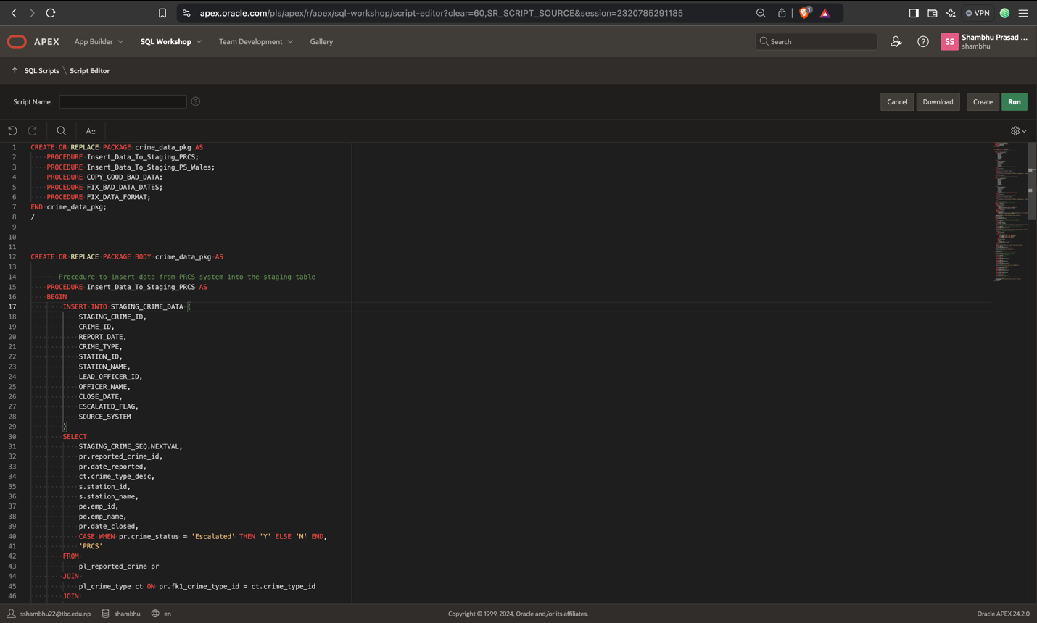

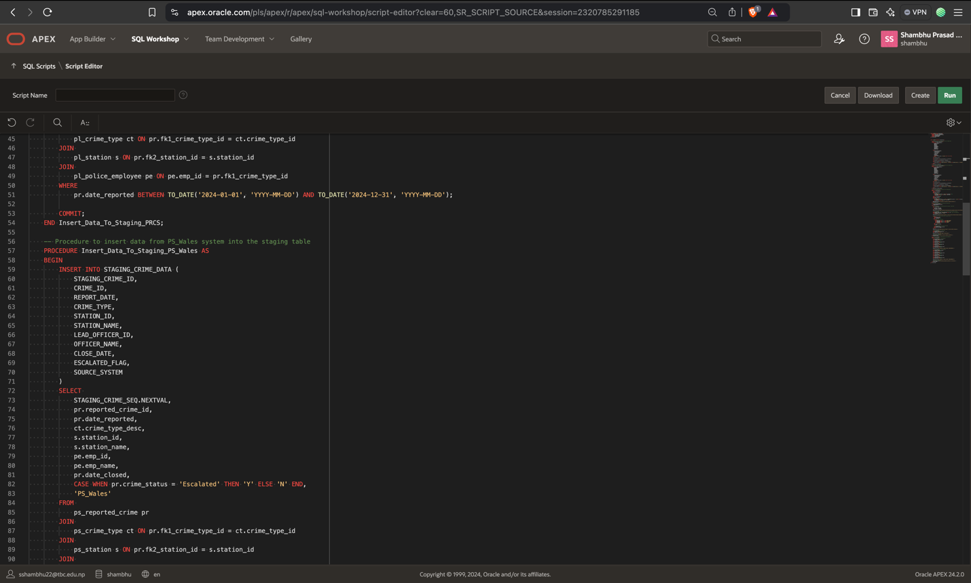

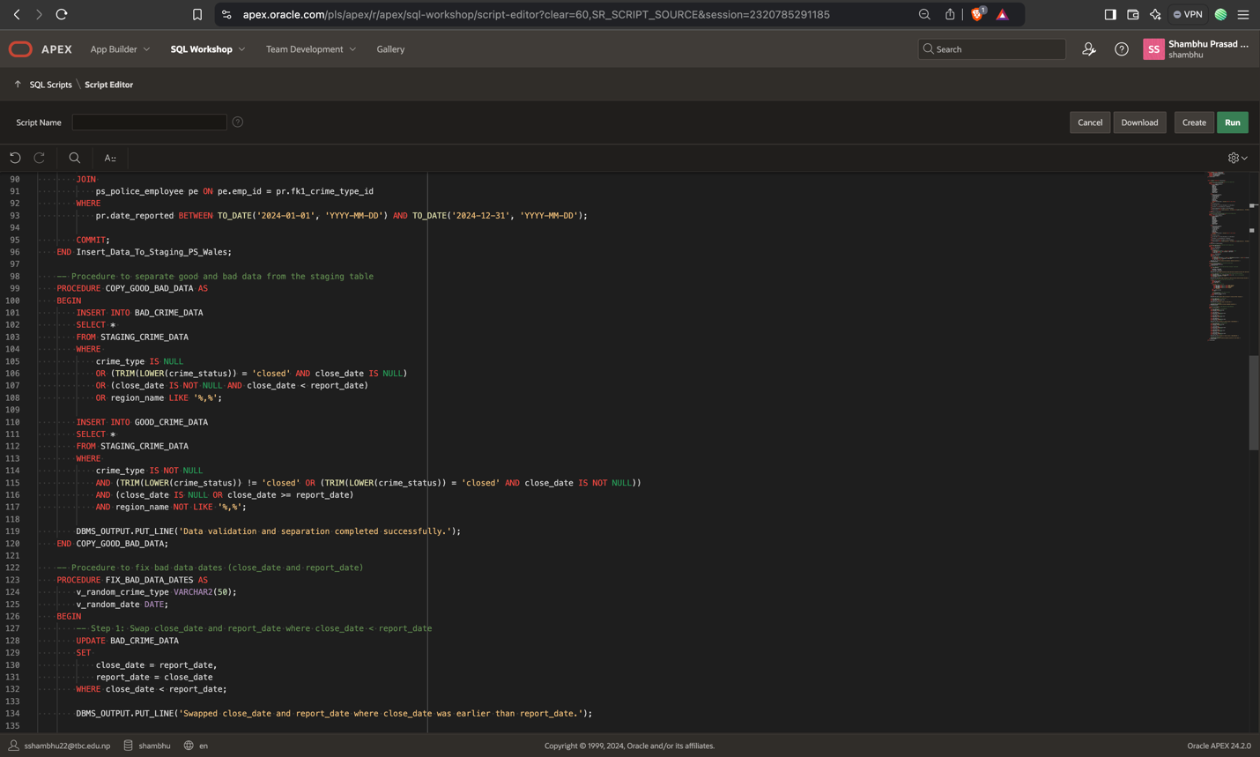

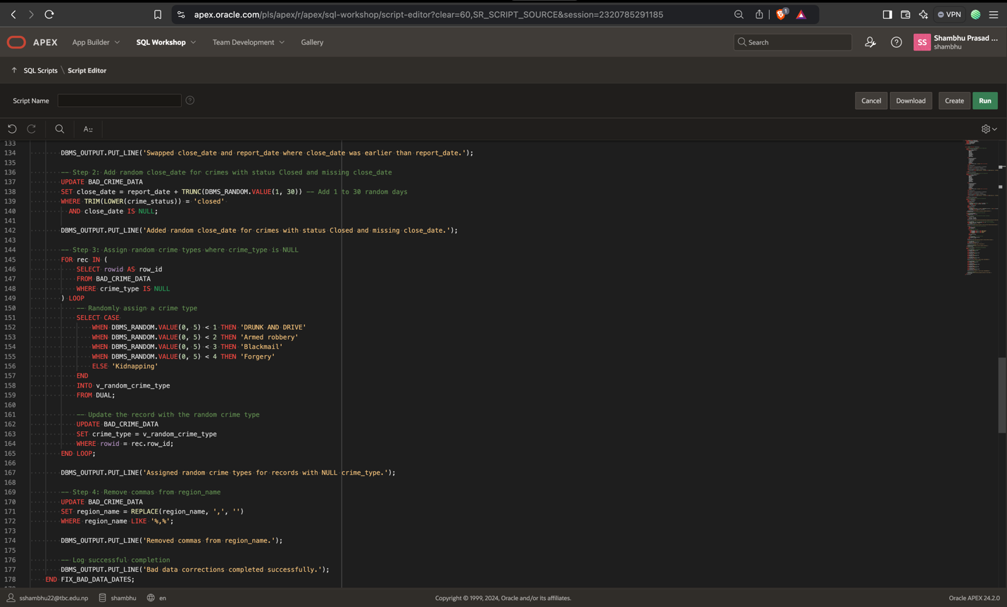

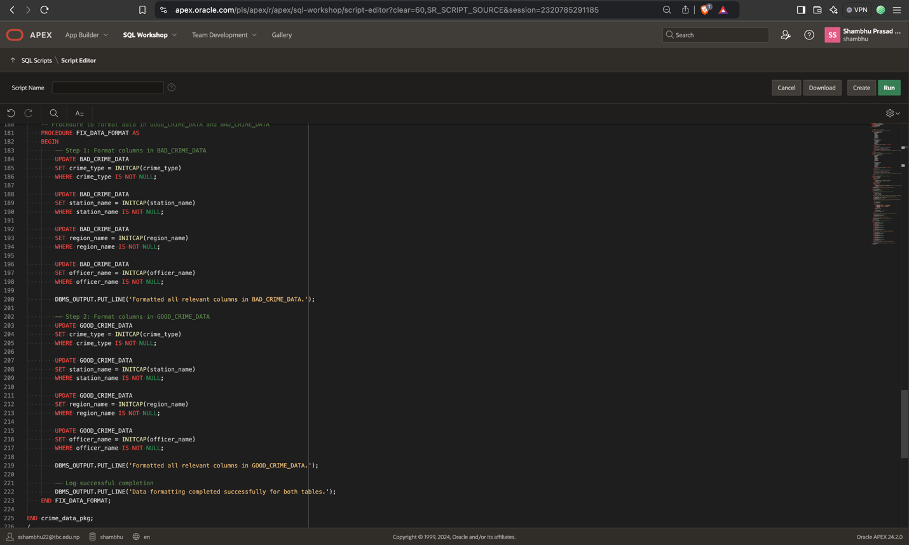

This code defines a PL/SQL package called crime_data_pkg, which contains procedures to handle data operations related to crime data, such as inserting data into staging tables, separating good and bad data, fixing bad data, and formatting the data.

**Key Procedures:**

1. **Insert_Data_To_Staging_PRCS:**
   * This procedure inserts crime data from the PRCS system into the STAGING_CRIME_DATA table. It joins several source tables (pl_reported_crime, pl_crime_type, pl_station, pl_police_employee) and inserts relevant fields.
2. **Insert_Data_To_Staging_PS_Wales:**
   * Similar to the previous procedure, this inserts crime data from the PS_Wales system into the STAGING_CRIME_DATA table.
3. **COPY_GOOD_BAD_DATA:**
   * This procedure separates the data in the STAGING_CRIME_DATA table into **good** and **bad** data:
     + **Bad data** includes entries with missing or incorrect information (e.g., crime_type is null, close_date is before report_date, etc.).
     + **Good data** meets the validation criteria.
   * The bad and good data are inserted into BAD_CRIME_DATA and GOOD_CRIME_DATA tables, respectively.
4. **FIX_BAD_DATA_DATES:**
   * This procedure fixes bad data involving dates:
     + It swaps close_date and report_date where close_date is earlier than report_date.
     + It assigns random close_date for crimes marked as "closed" but with no close_date.
     + It assigns random crime types to records where crime_type is null.
     + It removes commas from region_name fields.
5. **FIX_DATA_FORMAT:**
   * This procedure formats the data in both GOOD_CRIME_DATA and BAD_CRIME_DATA tables:
     + It capitalizes the first letter of crime_type, station_name, region_name, and officer_name columns in both tables.

**Summary:**

This package manages crime data by:

1. Inserting data from different crime reporting systems into a staging table.
2. Separating good and bad data based on validation rules.
3. Fixing and correcting bad data, particularly in date fields and missing information.
4. Formatting the data for consistency and readability.